Billing Service Testing after version upgrade
1. Bill Controller

- Bill v2 search : http://localhost:8081/billing-service/bill/v2/_search?tenantId=pg.citya&consumerCode=SV-1013-001437&service=sv-services

Payload :-
curl --location 'http://localhost:8081/billing-service/bill/v2/_search?tenantId=pg.citya&consumerCode=SV-1013-001437&service=sv-services' \
--header 'accept: application/json, text/plain, */*' \
--header 'accept-language: en-US,en;q=0.9' \
--header 'content-type: application/json;charset=UTF-8' \
--header 'origin: https://niuatt.niua.in' \
--header 'priority: u=1, i' \
--header 'referer: https://niuatt.niua.in/sv-ui/employee/payment/collect/sv-services/SV-1013-001437' \
--header 'sec-ch-ua: "Chromium";v="136", "Google Chrome";v="136", "Not.A/Brand";v="99"' \
--header 'sec-ch-ua-mobile: ?0' \
--header 'sec-ch-ua-platform: "Linux"' \
--header 'sec-fetch-dest: empty' \
--header 'sec-fetch-mode: cors' \
--header 'sec-fetch-site: same-origin' \
--header 'user-agent: Mozilla/5.0 (X11; Linux x86_64) AppleWebKit/537.36 (KHTML, like Gecko) Chrome/136.0.0.0 Safari/537.36' \
--data '{
"RequestInfo": {
"apiId": "Rainmaker",
"authToken": "d1d09aa5-804d-4663-8aa5-9b35c633de3d",
"userInfo": {
"id": 781,
"uuid": "9ff0b9bc-ae68-4a4d-a7ac-83f95257dc2d",
"userName": "SV_CEMP",
"name": "Street Vending",
"mobileNumber": "9810010199",
"emailId": null,
"locale": null,
"type": "EMPLOYEE",
"roles": [
{
"name": "Employee",
"code": "EMPLOYEE",
"tenantId": "pg.citya"
},
{
"name": "SV CEMP ",
"code": "SVCEMP",
"tenantId": "pg.citya"
}
],
"active": true,
"tenantId": "pg.citya",
"permanentCity": null
},
"msgId": "1750415006167|en_IN",
"plainAccessRequest": {}
}
}'

Response:
{
"ResposneInfo": {
"apiId": "Rainmaker",
"ver": null,
"ts": null,
"resMsgId": null,
"msgId": "1750415006167|en_IN",
"status": "200 OK"
},
"Bill": [
{
"id": "94e9abe5-afbf-473e-9e7f-d102bf4179c8",
"userId": "661a381b-104c-452f-98ad-d02561865e0f",
"mobileNumber": "7876838366",
"payerName": "khalid",
"payerAddress": null,
"payerEmail": null,
"status": "PAID",
"totalAmount": 1500.00,
"businessService": "sv-services",
"billNumber": "BILL-012784",
"billDate": 1750656370404,
"consumerCode": "SV-1013-001437",
"additionalDetails": null,
"billDetails": [
{
"id": "2063d18d-44af-4035-8f98-422b41be1486",
"tenantId": "pg.citya",
"demandId": "2260600f-5fab-4917-9a0a-1d569e382623",
"billId": "94e9abe5-afbf-473e-9e7f-d102bf4179c8",
"expiryDate": 1750703399404,
"amount": 1500.00,
"amountPaid": null,
"fromPeriod": 1750397831215,
"toPeriod": 1781933831215,
"additionalDetails": null,
"billAccountDetails": [
{
"id": "82b5719e-3fb9-48ef-96c0-e8febb2cae39",
"tenantId": "pg.citya",
"billDetailId": "2063d18d-44af-4035-8f98-422b41be1486",
"demandDetailId": "197f3584-b248-4528-a934-a7ac7f8a2157",
"order": 0,
"amount": 1500.00,
"adjustedAmount": 0.00,
"taxHeadCode": "SV_STREET_VENDING_REGISTRATION_FEE",
"additionalDetails": null,
"auditDetails": null
}
]
}
],
"tenantId": "pg.citya",
"fileStoreId": null,
"auditDetails": {
"createdBy": "9ff0b9bc-ae68-4a4d-a7ac-83f95257dc2d",
"lastModifiedBy": "9ff0b9bc-ae68-4a4d-a7ac-83f95257dc2d",
"createdTime": 1750656370404,
"lastModifiedTime": 1750656370404
}
}
]
}

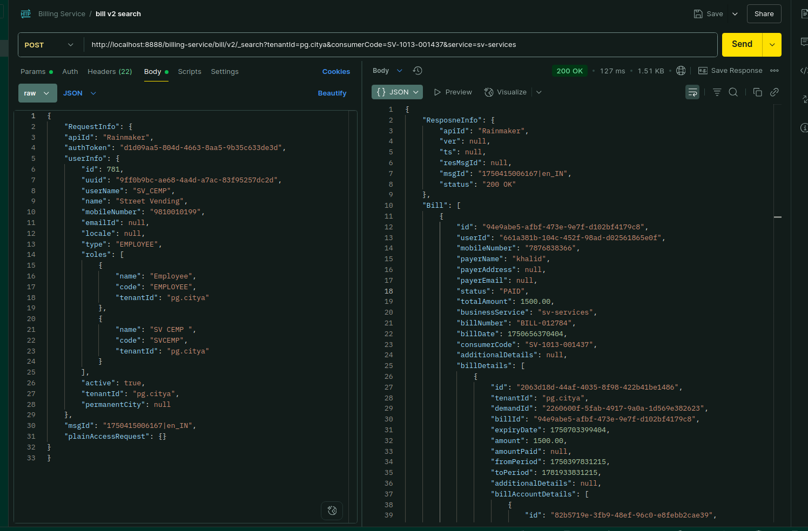

Environment via port-forward:

Response:
{
"ResposneInfo": {
"apiId": "Rainmaker",
"ver": null,
"ts": null,
"resMsgId": null,
"msgId": "1750415006167|en_IN",
"status": "200 OK"
},
"Bill": [
{
"id": "94e9abe5-afbf-473e-9e7f-d102bf4179c8",
"userId": "661a381b-104c-452f-98ad-d02561865e0f",
"mobileNumber": "7876838366",
"payerName": "khalid",
"payerAddress": null,
"payerEmail": null,
"status": "PAID",
"totalAmount": 1500.00,
"businessService": "sv-services",
"billNumber": "BILL-012784",
"billDate": 1750656370404,
"consumerCode": "SV-1013-001437",
"additionalDetails": null,
"billDetails": [
{
"id": "2063d18d-44af-4035-8f98-422b41be1486",
"tenantId": "pg.citya",
"demandId": "2260600f-5fab-4917-9a0a-1d569e382623",
"billId": "94e9abe5-afbf-473e-9e7f-d102bf4179c8",
"expiryDate": 1750703399404,
"amount": 1500.00,
"amountPaid": null,
"fromPeriod": 1750397831215,
"toPeriod": 1781933831215,
"additionalDetails": null,
"billAccountDetails": [
{
"id": "82b5719e-3fb9-48ef-96c0-e8febb2cae39",
"tenantId": "pg.citya",
"billDetailId": "2063d18d-44af-4035-8f98-422b41be1486",
"demandDetailId": "197f3584-b248-4528-a934-a7ac7f8a2157",
"order": 0,
"amount": 1500.00,
"adjustedAmount": 0.00,
"taxHeadCode": "SV_STREET_VENDING_REGISTRATION_FEE",
"additionalDetails": null,
"auditDetails": null
}
]
}
],
"tenantId": "pg.citya",
"fileStoreId": null,
"auditDetails": {
"createdBy": "9ff0b9bc-ae68-4a4d-a7ac-83f95257dc2d",
"lastModifiedBy": "9ff0b9bc-ae68-4a4d-a7ac-83f95257dc2d",
"createdTime": 1750656370404,
"lastModifiedTime": 1750656370404
}
}
]
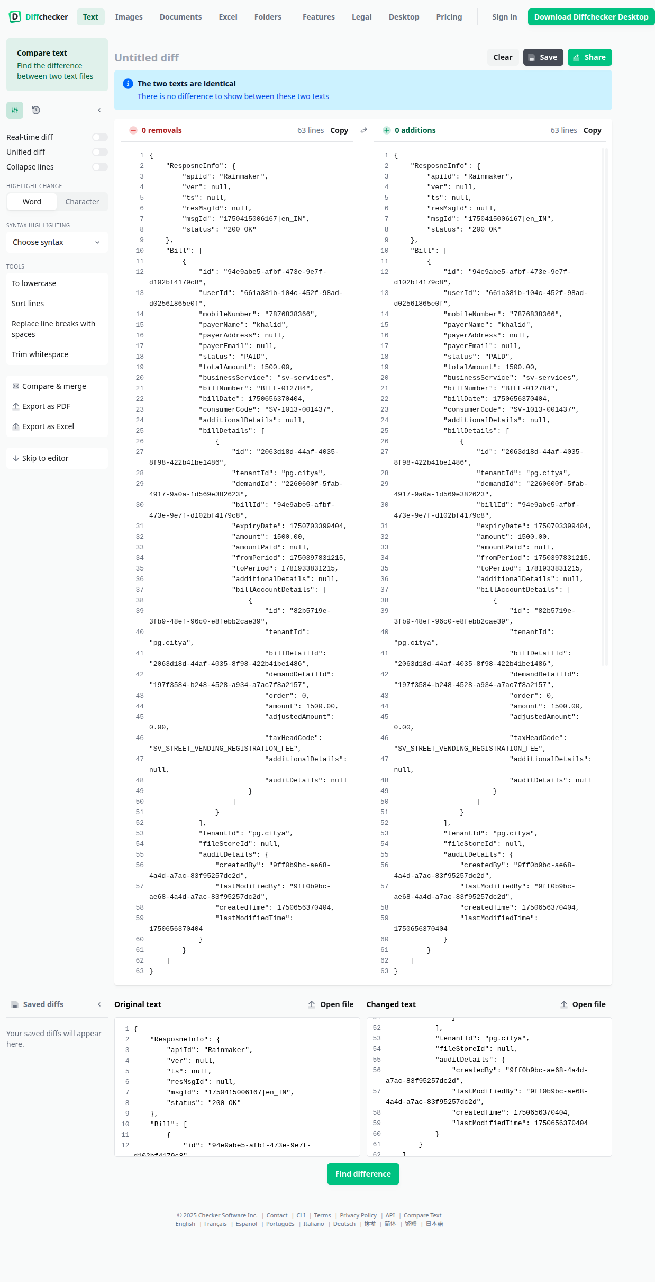
}

- Bill v2 create: http://localhost:8081/billing-service/bill/v2/_create

Payload Curl:-
curl --location 'http://localhost:8081/billing-service/bill/v2/_create' \
--header 'accept: application/json, text/plain, */*' \
--header 'accept-language: en-US,en;q=0.9' \
--header 'content-type: application/json;charset=UTF-8' \
--header 'origin: https://niuatt.niua.in' \
--header 'priority: u=1, i' \
--header 'referer: https://niuatt.niua.in/sv-ui/employee/payment/collect/sv-services/SV-1013-001437' \
--header 'sec-ch-ua: "Chromium";v="136", "Google Chrome";v="136", "Not.A/Brand";v="99"' \
--header 'sec-ch-ua-mobile: ?0' \
--header 'sec-ch-ua-platform: "Linux"' \
--header 'sec-fetch-dest: empty' \
--header 'sec-fetch-mode: cors' \
--header 'sec-fetch-site: same-origin' \
--header 'user-agent: Mozilla/5.0 (X11; Linux x86_64) AppleWebKit/537.36 (KHTML, like Gecko) Chrome/136.0.0.0 Safari/537.36' \
--data '{
"RequestInfo": {
"apiId": "Rainmaker",
"authToken": "d1d09aa5-804d-4663-8aa5-9b35c633de3d",
"userInfo": {
"id": 781,
"uuid": "9ff0b9bc-ae68-4a4d-a7ac-83f95257dc2d",
"userName": "SV_CEMP",
"name": "Street Vending",
"mobileNumber": "9810010199",
"emailId": null,
"locale": null,
"type": "EMPLOYEE",
"roles": [
{
"name": "Employee",
"code": "EMPLOYEE",
"tenantId": "pg.citya"
},
{
"name": "SV CEMP ",
"code": "SVCEMP",
"tenantId": "pg.citya"
}
],
"active": true,
"tenantId": "pg.citya",
"permanentCity": null
},
"msgId": "1750415006167|en_IN",
"plainAccessRequest": {}
},
"Bills": [
{
"id": "string",
"userId": "string",
"mobileNumber": "4458530308",
"payerName": "string",
"payerAddress": "string",
"payerEmail": "string",
"status": "ACTIVE",
"totalAmount": 0,
"businessService": "sv-services",
"billNumber": "string",
"billDate": 0,
"consumerCode": "SV-1013-001437",
"additionalDetails": {},
"billDetails": [
{
"id": "string",
"tenantId": "string",
"demandId": "string",
"billId": "string",
"expiryDate": 0,
"amount": 0,
"amountPaid": 0,
"fromPeriod": 0,
"toPeriod": 0,
"additionalDetails": {},
"billAccountDetails": [
{
"id": "string",
"tenantId": "string",
"billDetailId": "string",
"demandDetailId": "string",
"order": 0,
"amount": 0,
"adjustedAmount": 0,
"taxHeadCode": "string",
"additionalDetails": {},
"auditDetails": {
"createdBy": "string",
"lastModifiedBy": "string",
"createdTime": 0,
"lastModifiedTime": 0
}
}
]
}
],
"tenantId": "string",
"fileStoreId": "string",
"auditDetails": {
"createdBy": "string",
"lastModifiedBy": "string",
"createdTime": 0,
"lastModifiedTime": 0
}
}
]

}'

Response:-

{
"ResposneInfo": null,
"Bill": [
{
"id": "16e0f647-f9cc-43c0-ba6f-d3717fd216ae",
"userId": "string",
"mobileNumber": "4458530308",
"payerName": "string",
"payerAddress": "string",
"payerEmail": "string",
"status": "ACTIVE",
"totalAmount": 0,
"businessService": "sv-services",
"billNumber": "8",
"billDate": 0,
"consumerCode": "SV-1013-001437",
"additionalDetails": {},
"billDetails": [
{
"id": "8917054f-5690-4990-bc9a-9f3712011a76",
"tenantId": "string",
"demandId": "string",
"billId": "16e0f647-f9cc-43c0-ba6f-d3717fd216ae",
"expiryDate": 0,
"amount": 0,
"amountPaid": 0,
"fromPeriod": 0,
"toPeriod": 0,
"additionalDetails": {},
"billAccountDetails": [
{
"id": "cd7e86ff-9559-4670-b674-45b8b8e38193",
"tenantId": "string",
"billDetailId": "8917054f-5690-4990-bc9a-9f3712011a76",
"demandDetailId": "string",
"order": 0,
"amount": 0,
"adjustedAmount": 0,
"taxHeadCode": "string",
"additionalDetails": {},
"auditDetails": {
"createdBy": "string",
"lastModifiedBy": "string",
"createdTime": 0,
"lastModifiedTime": 0
}
}
]
}
],
"tenantId": "string",
"fileStoreId": "string",
"auditDetails": {
"createdBy": "string",
"lastModifiedBy": "string",
"createdTime": 0,
"lastModifiedTime": 0
}
}
]
}

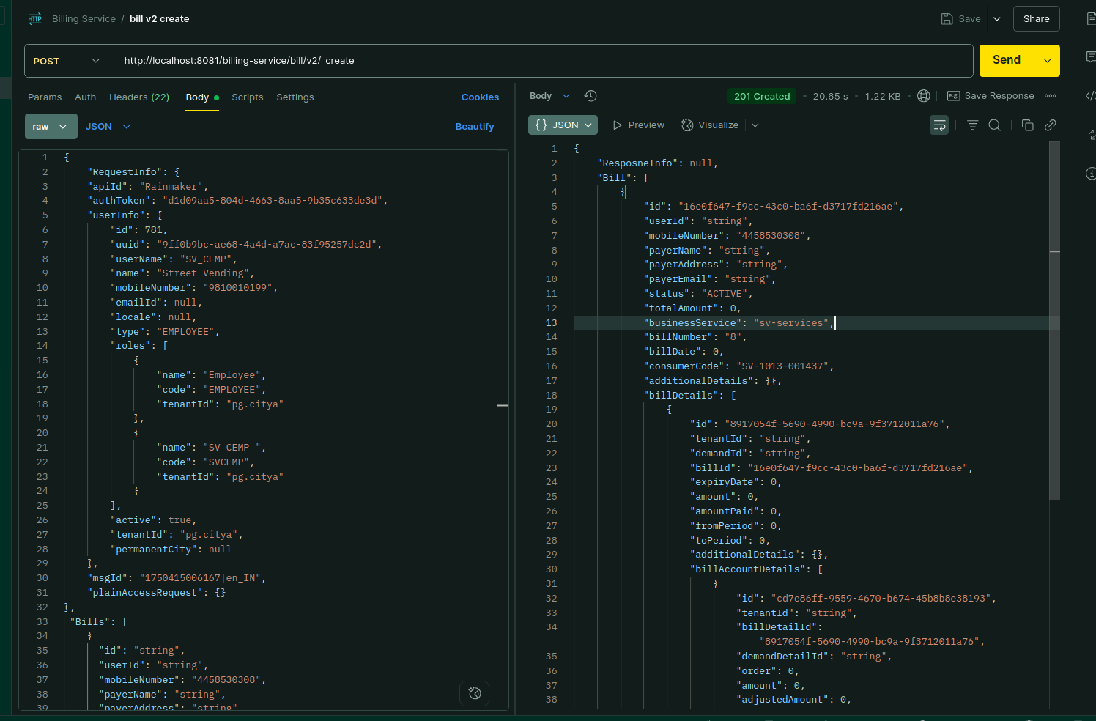
Environment via port-forward:

Response:
{
"ResposneInfo": null,
"Bill": [
{
"id": "16e0f647-f9cc-43c0-ba6f-d3717fd216ae",
"userId": "string",
"mobileNumber": "4458530308",
"payerName": "string",
"payerAddress": "string",
"payerEmail": "string",
"status": "ACTIVE",
"totalAmount": 0,
"businessService": "sv-services",
"billNumber": "8",
"billDate": 0,
"consumerCode": "SV-1013-001437",
"additionalDetails": {},
"billDetails": [
{
"id": "8917054f-5690-4990-bc9a-9f3712011a76",
"tenantId": "string",
"demandId": "string",
"billId": "16e0f647-f9cc-43c0-ba6f-d3717fd216ae",
"expiryDate": 0,
"amount": 0,
"amountPaid": 0,
"fromPeriod": 0,
"toPeriod": 0,
"additionalDetails": {},
"billAccountDetails": [
{
"id": "cd7e86ff-9559-4670-b674-45b8b8e38193",
"tenantId": "string",
"billDetailId": "8917054f-5690-4990-bc9a-9f3712011a76",
"demandDetailId": "string",
"order": 0,
"amount": 0,
"adjustedAmount": 0,
"taxHeadCode": "string",
"additionalDetails": {},
"auditDetails": {
"createdBy": "string",
"lastModifiedBy": "string",
"createdTime": 0,
"lastModifiedTime": 0
}
}
]
}
],
"tenantId": "string",
"fileStoreId": "string",
"auditDetails": {
"createdBy": "string",
"lastModifiedBy": "string",
"createdTime": 0,
"lastModifiedTime": 0
}
}
]
}

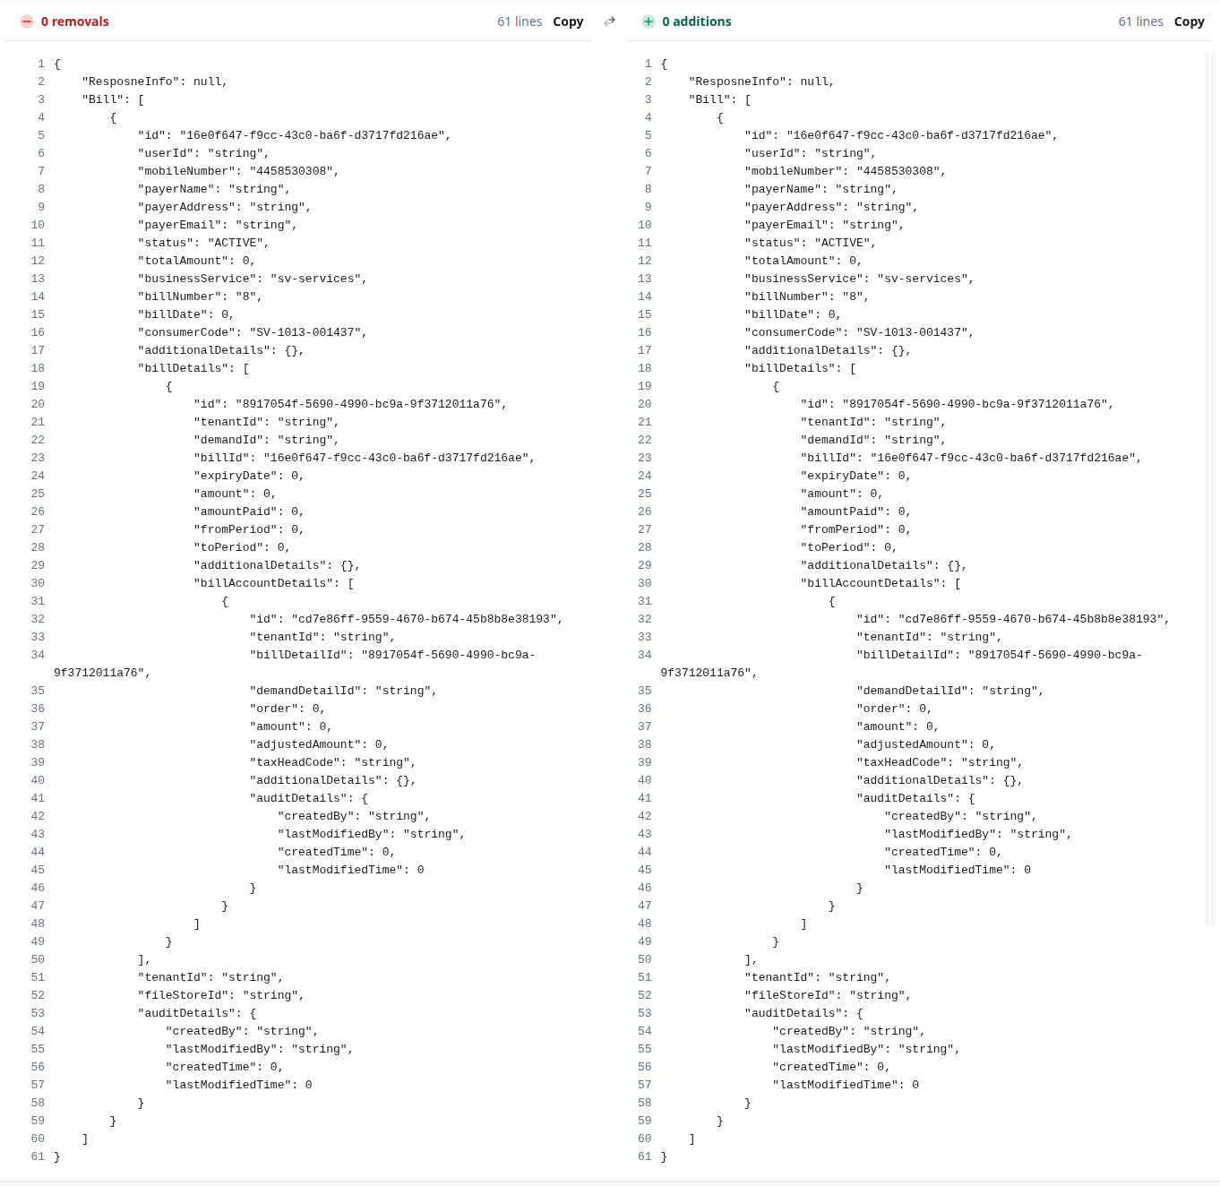

- Bill v2 cancelbill:http://localhost:8888/billing-service/bill/v2/_cancelbill

Payload Curl -
curl --location 'http://localhost:8081/billing-service/bill/v2/_cancelbill' \
--header 'accept: application/json, text/plain, */*' \
--header 'accept-language: en-US,en;q=0.9' \
--header 'content-type: application/json;charset=UTF-8' \
--header 'origin: https://niuatt.niua.in' \
--header 'priority: u=1, i' \
--header 'referer: https://niuatt.niua.in/sv-ui/employee/payment/collect/sv-services/SV-1013-001437' \
--header 'sec-ch-ua: "Chromium";v="136", "Google Chrome";v="136", "Not.A/Brand";v="99"' \
--header 'sec-ch-ua-mobile: ?0' \
--header 'sec-ch-ua-platform: "Linux"' \
--header 'sec-fetch-dest: empty' \
--header 'sec-fetch-mode: cors' \
--header 'sec-fetch-site: same-origin' \
--header 'user-agent: Mozilla/5.0 (X11; Linux x86_64) AppleWebKit/537.36 (KHTML, like Gecko) Chrome/136.0.0.0 Safari/537.36' \
--data '{
"RequestInfo": {
"apiId": "Rainmaker",
"authToken": "d1d09aa5-804d-4663-8aa5-9b35c633de3d",
"userInfo": {
"id": 781,
"uuid": "9ff0b9bc-ae68-4a4d-a7ac-83f95257dc2d",
"userName": "SV_CEMP",
"name": "Street Vending",
"mobileNumber": "9810010199",
"emailId": null,
"locale": null,
"type": "EMPLOYEE",
"roles": [
{
"name": "Employee",
"code": "EMPLOYEE",
"tenantId": "pg.citya"
},
{
"name": "SV CEMP ",
"code": "SVCEMP",
"tenantId": "pg.citya"
}
],
"active": true,
"tenantId": "pg.citya",
"permanentCity": null
},
"msgId": "1750415006167|en_IN",
"plainAccessRequest": {}
},
"updateBillCriteria": {
"tenantId": "pg.citya",
"consumerCodes": [
"SV-1013-001438"
],
"businessService": "sv-services",
"additionalDetails": {
"reason": "no reason",
"reasonMessage": "no reason"
},
"billIds": [

],
"statusToBeUpdated": "ACTIVE"
}
}'

Response:
{
"ResponseInfo": {
"apiId": "Rainmaker",
"ver": null,
"ts": null,
"resMsgId": null,
"msgId": "1750415006167|en_IN",
"status": "200 OK"
},
"Message": "Successfully cancelled 1 Active bills for given consumer codes"
}
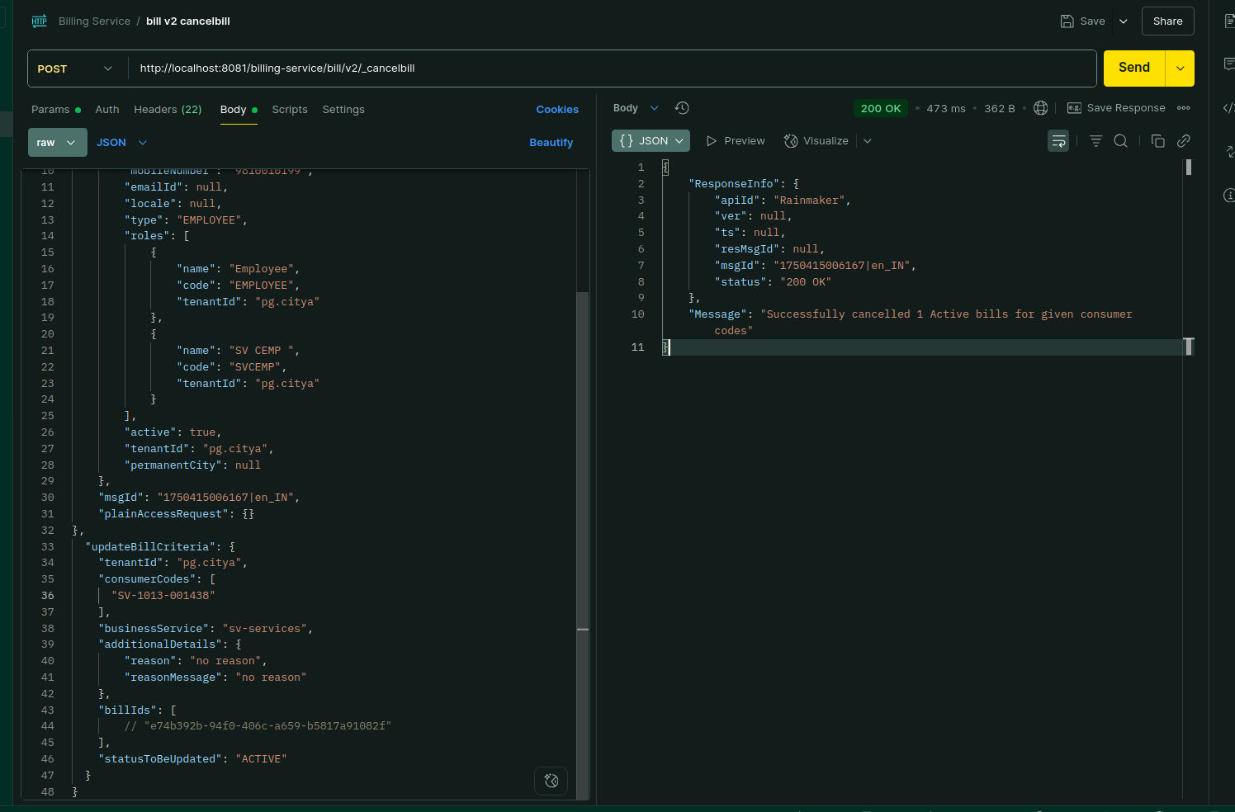

Environment via port-forward:

Response:
{
"ResponseInfo": {
"apiId": "Rainmaker",
"ver": null,
"ts": null,
"resMsgId": null,
"msgId": "1750415006167|en_IN",
"status": "200 OK"
},
"Message": "Successfully cancelled 1 Active bills for given consumer codes"
}

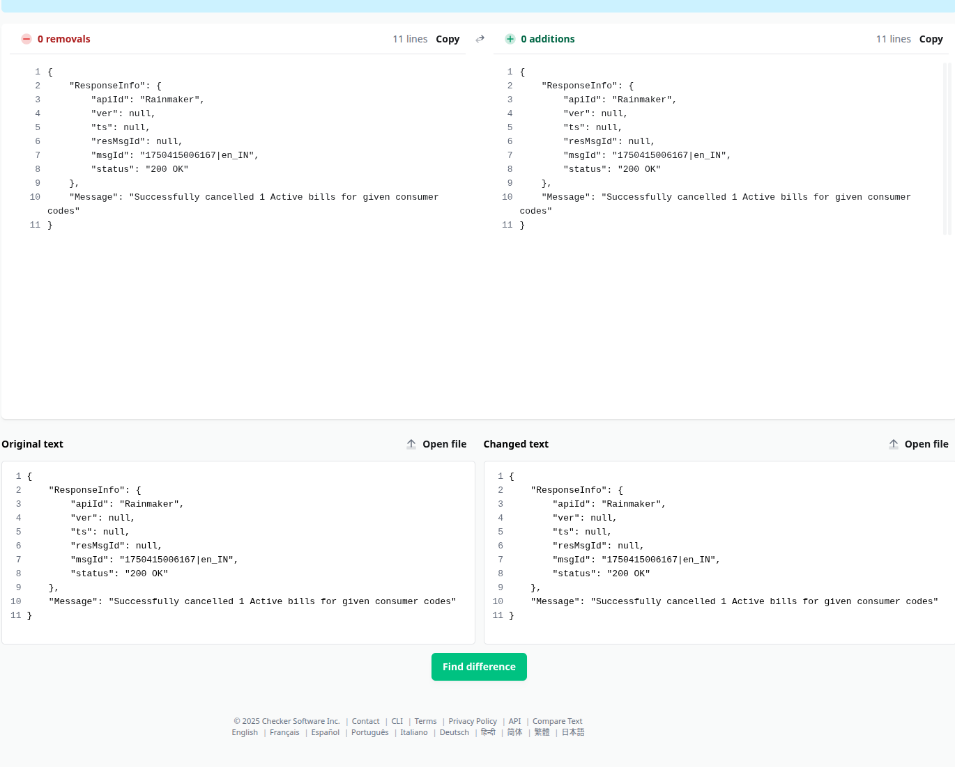

-Bill v2 fetchbill:

Payload -curl:
curl --location 'http://localhost:8081/billing-service/bill/v2/_fetchbill?tenantId=pg.citya&consumerCode=ADV-1013-000505&businessService=adv-services&_=1751432957533' \
--header 'accept: application/json, text/plain, */*' \
--header 'accept-language: en-US,en;q=0.9' \
--header 'content-type: application/json;charset=UTF-8' \
--header 'origin: https://niuatt.niua.in' \
--header 'priority: u=1, i' \
--header 'referer: https://niuatt.niua.in/digit-ui/citizen/payment/my-bills/adv-services/ADV-1013-000505' \
--header 'sec-ch-ua: "Chromium";v="136", "Google Chrome";v="136", "Not.A/Brand";v="99"' \
--header 'sec-ch-ua-mobile: ?0' \
--header 'sec-ch-ua-platform: "Linux"' \
--header 'sec-fetch-dest: empty' \
--header 'sec-fetch-mode: cors' \
--header 'sec-fetch-site: same-origin' \
--header 'user-agent: Mozilla/5.0 (X11; Linux x86_64) AppleWebKit/537.36 (KHTML, like Gecko) Chrome/136.0.0.0 Safari/537.36' \
--data-raw '{
"RequestInfo":{
"apiId": "Rainmaker",
"authToken": "0a3d3b8e-c8c6-4154-8895-c666e0f6d879",
"userInfo": {
"id": 811,
"uuid": "f789d679-352d-4aec-8198-4d61af1e0566",
"userName": "8010012414",
"name": "OWNER",
"mobileNumber": "8010012414",
"emailId": "cghvjbnk@gmail.com",
"locale": null,
"type": "CITIZEN",
"roles": [
{
"name": "Citizen",
"code": "CITIZEN",
"tenantId": "pg"
}
],
"active": true,
"tenantId": "pg",
"permanentCity": null
},
"msgId": "1751432955173|en_IN",
"plainAccessRequest": {}
}
}'

Response:
{
"ResposneInfo": {
"apiId": "Rainmaker",
"ver": null,
"ts": null,
"resMsgId": null,
"msgId": "1751432955173|en_IN",
"status": "200 OK"
},
"Bill": [
{
"id": "ab4b2770-6f78-47bb-ac2b-9a591ceec85c",
"userId": "f789d679-352d-4aec-8198-4d61af1e0566",
"mobileNumber": "8010012414",
"payerName": "OWNER",
"payerAddress": null,
"payerEmail": null,
"status": "ACTIVE",
"totalAmount": 107970.00,
"businessService": "adv-services",
"billNumber": "BILL-013760",
"billDate": 1751432957725,
"consumerCode": "ADV-1013-000505",
"additionalDetails": null,
"billDetails": [
{
"id": "32482bed-7f45-4502-95b7-f0e7b57de013",
"tenantId": "pg.citya",
"demandId": "7a27557e-edee-43da-a448-dbdac5276a5a",
"billId": "ab4b2770-6f78-47bb-ac2b-9a591ceec85c",
"expiryDate": 1751480999725,
"amount": 107970.00,
"amountPaid": null,
"fromPeriod": 1750935505127,
"toPeriod": 1756146600000,
"additionalDetails": null,
"billAccountDetails": [
{
"id": "356c76a9-9996-49b1-9af7-8b04144a5560",
"tenantId": "pg.citya",
"billDetailId": "32482bed-7f45-4502-95b7-f0e7b57de013",
"demandDetailId": "c9d37dc3-72e0-49fb-bd7f-58ad41b26638",
"order": 0,
"amount": 91500.00,
"adjustedAmount": 0.00,
"taxHeadCode": "ADV_BOOKING_FEES",
"additionalDetails": null,
"auditDetails": null
},
{
"id": "3fdf24ea-62b8-4e96-9e86-53b80a9094ee",
"tenantId": "pg.citya",
"billDetailId": "32482bed-7f45-4502-95b7-f0e7b57de013",
"demandDetailId": "4ab3dc44-eee9-4cd4-b742-5a209f2a6be0",
"order": 0,
"amount": 8235.00,
"adjustedAmount": 0.00,
"taxHeadCode": "ADV_SGST",
"additionalDetails": null,
"auditDetails": null
},
{
"id": "77462c85-a628-4a14-ba9b-126c9791b018",
"tenantId": "pg.citya",
"billDetailId": "32482bed-7f45-4502-95b7-f0e7b57de013",
"demandDetailId": "69efd8cb-c090-4736-a411-a80dd8e1e3e7",
"order": 0,
"amount": 8235.00,
"adjustedAmount": 0.00,
"taxHeadCode": "ADV_CGST",
"additionalDetails": null,
"auditDetails": null
}
]
}
],
"tenantId": "pg.citya",
"fileStoreId": null,
"auditDetails": {
"createdBy": "f789d679-352d-4aec-8198-4d61af1e0566",
"lastModifiedBy": "f789d679-352d-4aec-8198-4d61af1e0566",
"createdTime": 1751432957725,
"lastModifiedTime": 1751432957725
}
}
]
}
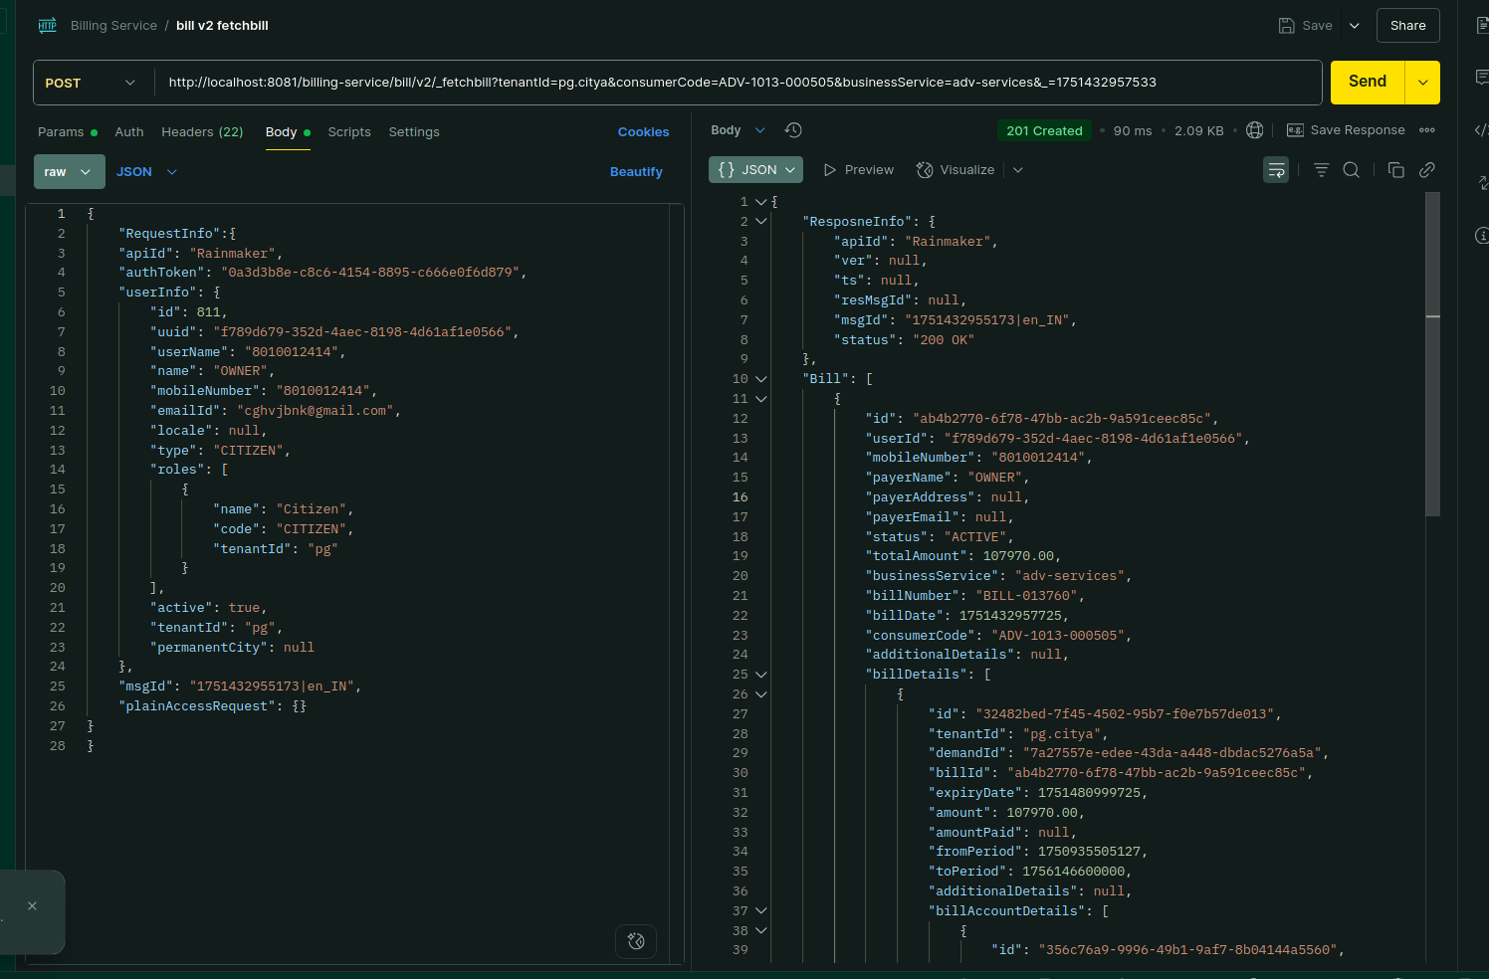

Environment via Port-forward:

Response:
{
"ResposneInfo": {
"apiId": "Rainmaker",
"ver": null,
"ts": null,
"resMsgId": null,
"msgId": "1751432955173|en_IN",
"status": "200 OK"
},
"Bill": [
{
"id": "ab4b2770-6f78-47bb-ac2b-9a591ceec85c",
"userId": "f789d679-352d-4aec-8198-4d61af1e0566",
"mobileNumber": "8010012414",
"payerName": "OWNER",
"payerAddress": null,
"payerEmail": null,
"status": "ACTIVE",
"totalAmount": 107970.00,
"businessService": "adv-services",
"billNumber": "BILL-013760",
"billDate": 1751432957725,
"consumerCode": "ADV-1013-000505",
"additionalDetails": null,
"billDetails": [
{
"id": "32482bed-7f45-4502-95b7-f0e7b57de013",
"tenantId": "pg.citya",
"demandId": "7a27557e-edee-43da-a448-dbdac5276a5a",
"billId": "ab4b2770-6f78-47bb-ac2b-9a591ceec85c",
"expiryDate": 1751480999725,
"amount": 107970.00,
"amountPaid": null,
"fromPeriod": 1750935505127,
"toPeriod": 1756146600000,
"additionalDetails": null,
"billAccountDetails": [
{
"id": "356c76a9-9996-49b1-9af7-8b04144a5560",
"tenantId": "pg.citya",
"billDetailId": "32482bed-7f45-4502-95b7-f0e7b57de013",
"demandDetailId": "c9d37dc3-72e0-49fb-bd7f-58ad41b26638",
"order": 0,
"amount": 91500.00,
"adjustedAmount": 0.00,
"taxHeadCode": "ADV_BOOKING_FEES",
"additionalDetails": null,
"auditDetails": null
},
{
"id": "3fdf24ea-62b8-4e96-9e86-53b80a9094ee",
"tenantId": "pg.citya",
"billDetailId": "32482bed-7f45-4502-95b7-f0e7b57de013",
"demandDetailId": "4ab3dc44-eee9-4cd4-b742-5a209f2a6be0",
"order": 0,
"amount": 8235.00,
"adjustedAmount": 0.00,
"taxHeadCode": "ADV_SGST",
"additionalDetails": null,
"auditDetails": null
},
{
"id": "77462c85-a628-4a14-ba9b-126c9791b018",
"tenantId": "pg.citya",
"billDetailId": "32482bed-7f45-4502-95b7-f0e7b57de013",
"demandDetailId": "69efd8cb-c090-4736-a411-a80dd8e1e3e7",
"order": 0,
"amount": 8235.00,
"adjustedAmount": 0.00,
"taxHeadCode": "ADV_CGST",
"additionalDetails": null,
"auditDetails": null
}
]
}
],
"tenantId": "pg.citya",
"fileStoreId": null,
"auditDetails": {
"createdBy": "f789d679-352d-4aec-8198-4d61af1e0566",
"lastModifiedBy": "f789d679-352d-4aec-8198-4d61af1e0566",
"createdTime": 1751432957725,
"lastModifiedTime": 1751432957725
}
}
]
}

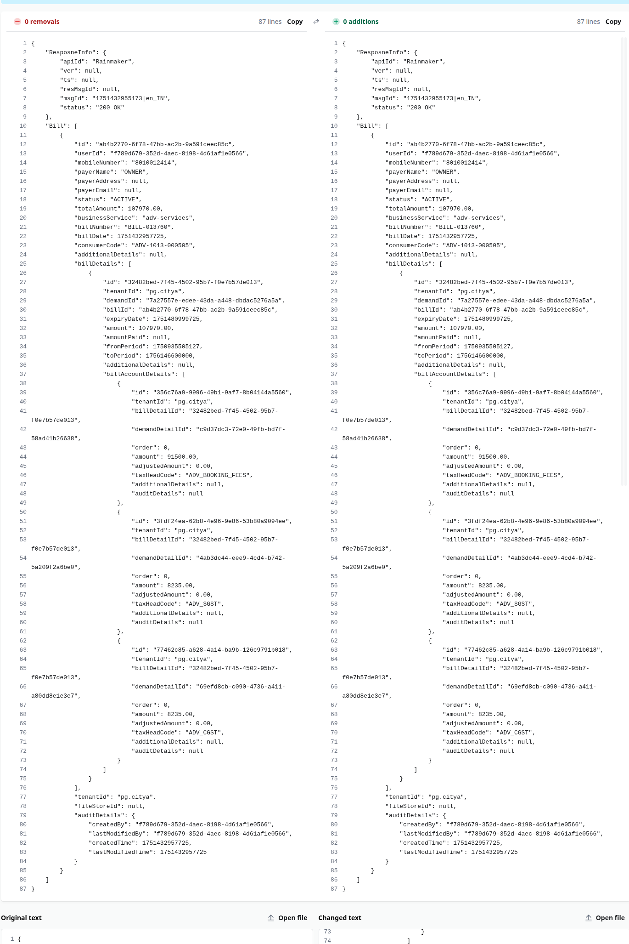
-------------

Amendment Controller:

-Amendment Search:

Payload -curl:
curl --location 'http://localhost:8888/billing-service/amendment/_search?tenantId=pg.citya&consumerCode=string&businessService=WS' \
--header 'accept: application/json, text/plain, */*' \
--header 'accept-language: en-US,en;q=0.9' \
--header 'content-type: application/json;charset=UTF-8' \
--header 'origin: https://niuatt.niua.in' \
--header 'priority: u=1, i' \
--header 'referer: https://niuatt.niua.in/sv-ui/employee/payment/collect/sv-services/SV-1013-001437' \
--header 'sec-ch-ua: "Chromium";v="136", "Google Chrome";v="136", "Not.A/Brand";v="99"' \
--header 'sec-ch-ua-mobile: ?0' \
--header 'sec-ch-ua-platform: "Linux"' \
--header 'sec-fetch-dest: empty' \
--header 'sec-fetch-mode: cors' \
--header 'sec-fetch-site: same-origin' \
--header 'user-agent: Mozilla/5.0 (X11; Linux x86_64) AppleWebKit/537.36 (KHTML, like Gecko) Chrome/136.0.0.0 Safari/537.36' \
--data '{
"RequestInfo": {
"apiId": "Rainmaker",
"authToken": "d1d09aa5-804d-4663-8aa5-9b35c633de3d",
"userInfo": {
"id": 781,
"uuid": "9ff0b9bc-ae68-4a4d-a7ac-83f95257dc2d",
"userName": "SV_CEMP",
"name": "Street Vending",
"mobileNumber": "9810010199",
"emailId": null,
"locale": null,
"type": "EMPLOYEE",
"roles": [
{
"name": "Employee",
"code": "EMPLOYEE",
"tenantId": "pg.citya"
},
{
"name": "SV CEMP ",
"code": "SVCEMP",
"tenantId": "pg.citya"
}
],
"active": true,
"tenantId": "pg.citya",
"permanentCity": null
},
"msgId": "1750415006167|en_IN",
"plainAccessRequest": {}
}
}'

Response:
{
"ResponseInfo": {
"apiId": "Rainmaker",
"ver": null,
"ts": null,
"resMsgId": null,
"msgId": "1750415006167|en_IN",
"status": "200 OK"
},
"Amendments": [
{
"id": "2d990a57-b34a-4a64-879b-22b8cc8fa328",
"amendedDemandId": "string",
"tenantId": "pg.citya",
"consumerCode": "string",
"amendmentId": "CN-string-000008",
"businessService": "WS",
"amendmentReason": "COURT_CASE_SETTLEMENT",
"reasonDocumentNumber": "string",
"status": "INWORKFLOW",
"workflow": null,
"demandDetails": [
{
"id": "28e17155-d457-4a0d-8cc5-f79214a3d406",
"demandId": null,
"taxHeadMasterCode": "WS_CHARGE",
"taxAmount": 0.00,
"collectionAmount": 0,
"additionalDetails": null,
"auditDetails": null,
"tenantId": null
}
],
"documents": [
{
"id": "cca7bd58-f3e0-40ef-ab82-9ebbf4a35ce0",
"documentType": "string",
"fileStoreId": "string",
"documentUid": "string",
"additionalDetails": null
}
],
"effectiveFrom": 0,
"effectiveTill": 3,
"auditDetails": {
"createdBy": "9ff0b9bc-ae68-4a4d-a7ac-83f95257dc2d",
"lastModifiedBy": "9ff0b9bc-ae68-4a4d-a7ac-83f95257dc2d",
"createdTime": 1750744736790,
"lastModifiedTime": 1750744736790
},
"additionalDetails": {}
}
]
}

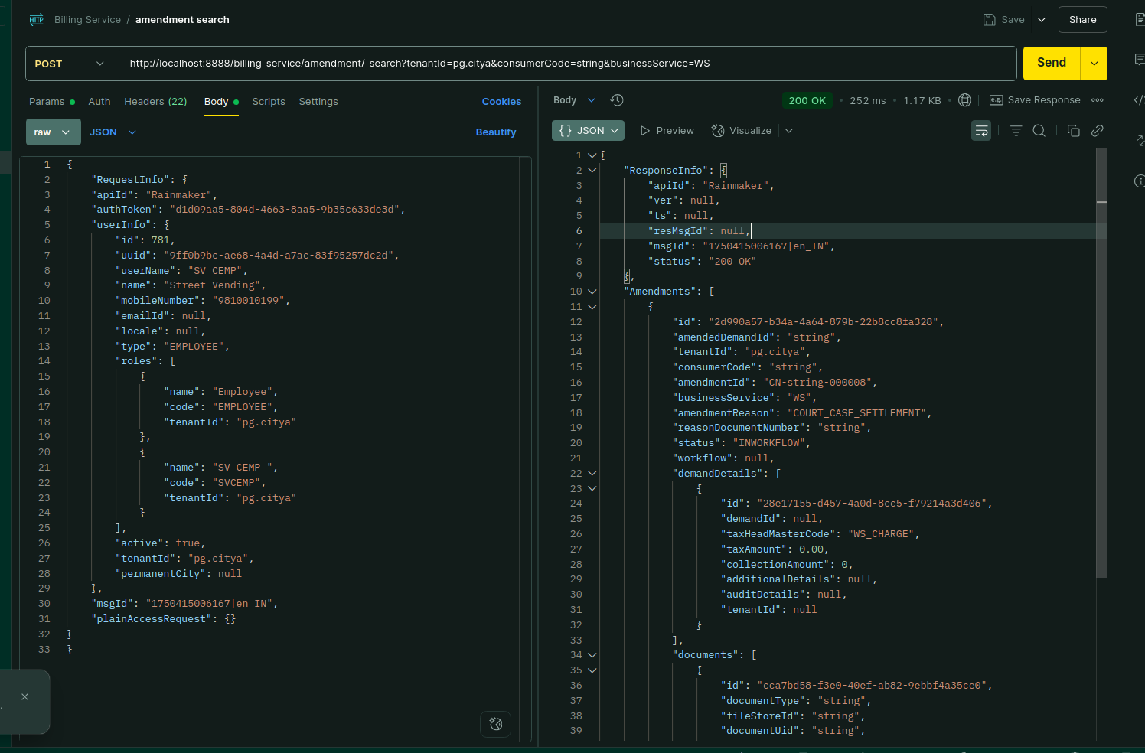

Environment via port-forward:

Response:
{
"ResponseInfo": {
"apiId": "Rainmaker",
"ver": null,
"ts": null,
"resMsgId": null,
"msgId": "1750415006167|en_IN",
"status": "200 OK"
},
"Amendments": [
{
"id": "2d990a57-b34a-4a64-879b-22b8cc8fa328",
"amendedDemandId": "string",
"tenantId": "pg.citya",
"consumerCode": "string",
"amendmentId": "CN-string-000008",
"businessService": "WS",
"amendmentReason": "COURT_CASE_SETTLEMENT",
"reasonDocumentNumber": "string",
"status": "INWORKFLOW",
"workflow": null,
"demandDetails": [
{
"id": "28e17155-d457-4a0d-8cc5-f79214a3d406",
"demandId": null,
"taxHeadMasterCode": "WS_CHARGE",
"taxAmount": 0.00,
"collectionAmount": 0,
"additionalDetails": null,
"auditDetails": null,
"tenantId": null
}
],
"documents": [
{
"id": "cca7bd58-f3e0-40ef-ab82-9ebbf4a35ce0",
"documentType": "string",
"fileStoreId": "string",
"documentUid": "string",
"additionalDetails": null
}
],
"effectiveFrom": 0,
"effectiveTill": 3,
"auditDetails": {
"createdBy": "9ff0b9bc-ae68-4a4d-a7ac-83f95257dc2d",
"lastModifiedBy": "9ff0b9bc-ae68-4a4d-a7ac-83f95257dc2d",
"createdTime": 1750744736790,
"lastModifiedTime": 1750744736790
},
"additionalDetails": {}
}
]
}

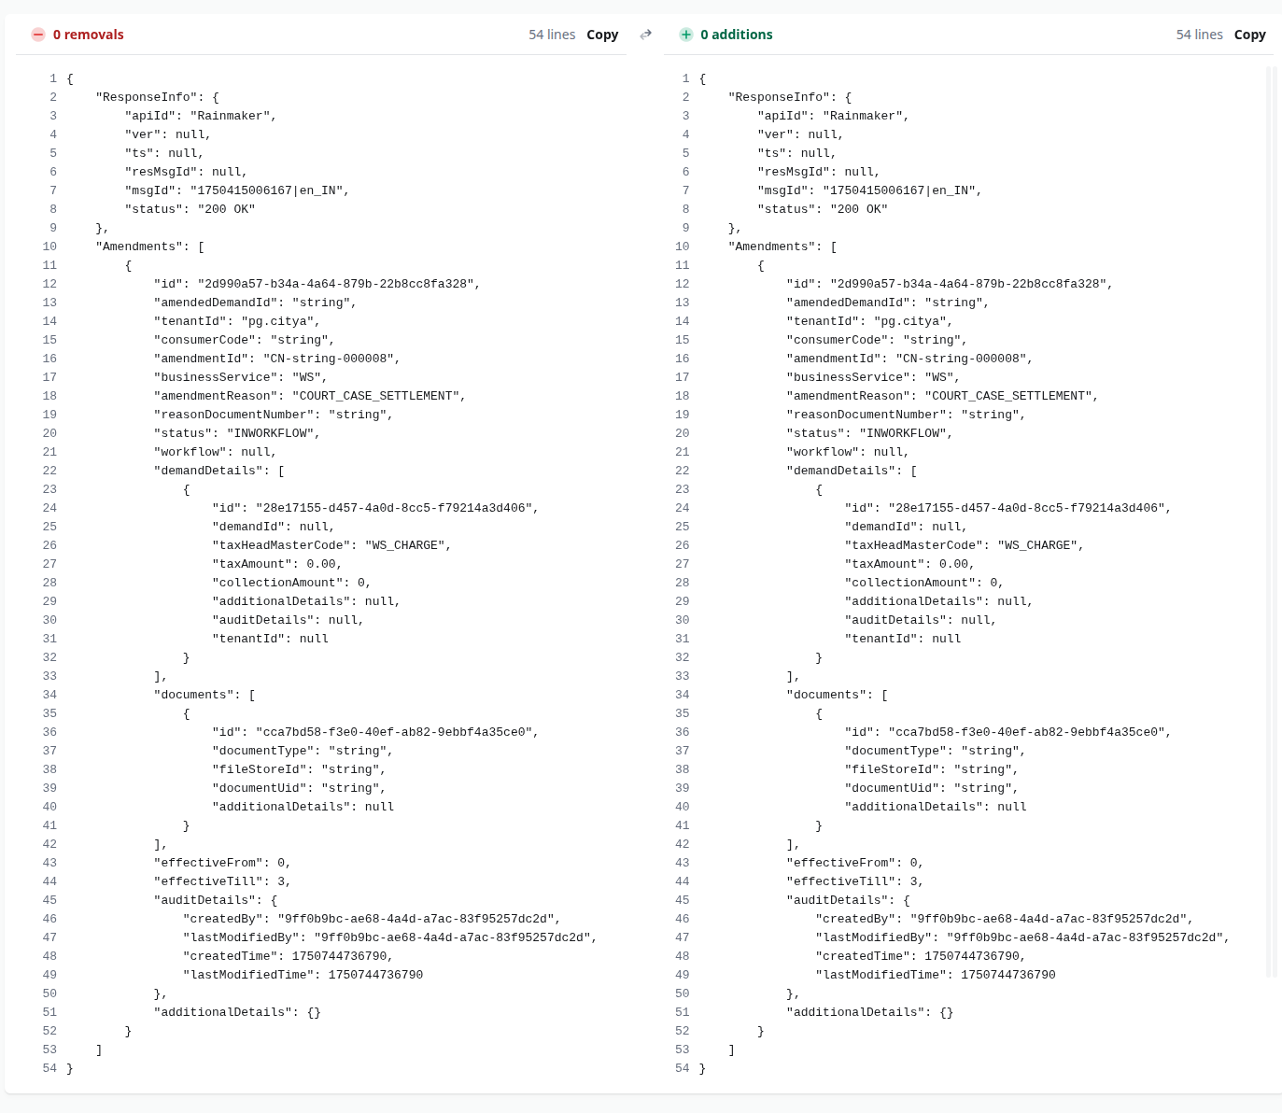

-Amendment Create:

Payload -curl:
curl --location 'http://localhost:8081/billing-service/amendment/_create' \
--header 'accept: application/json, text/plain, */*' \
--header 'accept-language: en-US,en;q=0.9' \
--header 'content-type: application/json;charset=UTF-8' \
--header 'origin: https://niuatt.niua.in' \
--header 'priority: u=1, i' \
--header 'referer: https://niuatt.niua.in/sv-ui/employee/payment/collect/sv-services/SV-1013-001437' \
--header 'sec-ch-ua: "Chromium";v="136", "Google Chrome";v="136", "Not.A/Brand";v="99"' \
--header 'sec-ch-ua-mobile: ?0' \
--header 'sec-ch-ua-platform: "Linux"' \
--header 'sec-fetch-dest: empty' \
--header 'sec-fetch-mode: cors' \
--header 'sec-fetch-site: same-origin' \
--header 'user-agent: Mozilla/5.0 (X11; Linux x86_64) AppleWebKit/537.36 (KHTML, like Gecko) Chrome/136.0.0.0 Safari/537.36' \
--data '{
"RequestInfo": {
"apiId": "Rainmaker",
"authToken": "d1d09aa5-804d-4663-8aa5-9b35c633de3d",
"userInfo": {
"id": 781,
"uuid": "9ff0b9bc-ae68-4a4d-a7ac-83f95257dc2d",
"userName": "SV_CEMP",
"name": "Street Vending",
"mobileNumber": "9810010199",
"emailId": null,
"locale": null,
"type": "EMPLOYEE",
"roles": [
{
"name": "Employee",
"code": "EMPLOYEE",
"tenantId": "pg.citya"
},
{
"name": "SV CEMP ",
"code": "WS_CEMP",
"tenantId": "pg.citya"
}
],
"active": true,
"tenantId": "pg.citya",
"permanentCity": null
},
"msgId": "1750415006167|en_IN",
"plainAccessRequest": {}
},
"Amendment": {
"id": "string",
"amendedDemandId": "string",
"tenantId": "pg.citya",
"consumerCode": "test5",
"amendmentId": "string",
"businessService": "WS",
"amendmentReason": "COURT_CASE_SETTLEMENT",
"reasonDocumentNumber": "string",
"status": "ACTIVE",
"workflow": {
"id": "string",
"tenantId": "pg.citya",
"businessService": "string",
"businessId": "string",
"action": "string",
"moduleName": "string",
"state": {
"auditDetails": {
"createdBy": "string",
"lastModifiedBy": "string",
"createdTime": 0,
"lastModifiedTime": 0
},
"uuid": "string",
"tenantId": "string",
"businessServiceId": "string",
"sla": 0,
"state": "string",
"applicationStatus": "string",
"docUploadRequired": true,
"isStartState": true,
"isTerminateState": true,
"isStateUpdatable": true,
"actions": [
{
"auditDetails": {
"createdBy": "string",
"lastModifiedBy": "string",
"createdTime": 0,
"lastModifiedTime": 0
},
"uuid": "string",
"tenantId": "string",
"currentState": "string",
"action": "string",
"nextState": "string",
"roles": [
"string"
]
}
]
},
"comment": "string",
"documents": [
{
"id": "string",
"documentType": "string",
"fileStoreId": "string",
"documentUid": "string",
"additionalDetails": {}
}
],
"assigner": {
"id": 0,
"userName": "string",
"name": "string",
"type": "string",
"mobileNumber": "string",
"emailId": "string",
"roles": [
{
"id": 0,
"name": "string",
"code": "string",
"tenantId": "string"
}
],
"tenantId": "string",
"uuid": "string"
},
"assignes": [
{
"id": 0,
"userName": "string",
"name": "string",
"type": "string",
"mobileNumber": "string",
"emailId": "string",
"roles": [
{
"id": 0,
"name": "string",
"code": "string",
"tenantId": "string"
}
],
"tenantId": "string",
"uuid": "string"
}
],
"nextActions": [
{
"auditDetails": {
"createdBy": "string",
"lastModifiedBy": "string",
"createdTime": 0,
"lastModifiedTime": 0
},
"uuid": "string",
"tenantId": "string",
"currentState": "string",
"action": "string",
"nextState": "string",
"roles": [
"string"
]
}
],
"stateSla": 0,
"businesssServiceSla": 0,
"previousStatus": "string",
"entity": {},
"auditDetails": {
"createdBy": "string",
"lastModifiedBy": "string",
"createdTime": 0,
"lastModifiedTime": 0
}
},
"demandDetails": [
{
"id": "string",
"demandId": "string",
"taxHeadMasterCode": "WS_CHARGE",
"taxAmount": 0,
"collectionAmount": 0,
"additionalDetails": {},
"auditDetails": {
"createdBy": "string",
"lastModifiedBy": "string",
"createdTime": 0,
"lastModifiedTime": 0
},
"tenantId": "string"
}
],
"documents": [
{
"id": "string",
"documentType": "string",
"fileStoreId": "string",
"documentUid": "string",
"additionalDetails": {}
}
],
"effectiveFrom": 0,
"effectiveTill": 10,
"auditDetails": {
"createdBy": "string",
"lastModifiedBy": "string",
"createdTime": 0,
"lastModifiedTime": 0
},
"additionalDetails": {}
}
}'

Response:
{
"ResponseInfo": {
"apiId": "Rainmaker",
"ver": null,
"ts": null,
"resMsgId": null,
"msgId": "1750415006167|en_IN",
"status": "201 CREATED"
},
"Amendments": [
{
"id": "c397b789-eaa9-47df-9b71-c63dd7937e09",
"amendedDemandId": "string",
"tenantId": "pg.citya",
"consumerCode": "test5",
"amendmentId": "CN-test5-000015",
"businessService": "WS",
"amendmentReason": "COURT_CASE_SETTLEMENT",
"reasonDocumentNumber": "string",
"status": "INWORKFLOW",
"workflow": {
"id": null,
"tenantId": "pg.citya",
"businessService": "WS.AMENDMENT",
"businessId": "CN-test5-000015",
"action": "OPEN",
"moduleName": "WS",
"state": null,
"comment": null,
"documents": null,
"assigner": null,
"assignes": null,
"nextActions": null,
"stateSla": null,
"businesssServiceSla": null,
"previousStatus": null,
"entity": null,
"auditDetails": null
},
"demandDetails": [
{
"id": "bae8c168-2c70-49f1-b9ef-368a8d1c568e",
"demandId": "string",
"taxHeadMasterCode": "WS_CHARGE",
"taxAmount": 0,
"collectionAmount": 0,
"additionalDetails": {},
"auditDetails": {
"createdBy": "string",
"lastModifiedBy": "string",
"createdTime": 0,
"lastModifiedTime": 0
},
"tenantId": "string"
}
],
"documents": [
{
"id": "565b3011-a1f3-4f3c-a653-52b9b1916d0c",
"documentType": "string",
"fileStoreId": "string",
"documentUid": "string",
"additionalDetails": {}
}
],
"effectiveFrom": 0,
"effectiveTill": 10,
"auditDetails": {
"createdBy": "9ff0b9bc-ae68-4a4d-a7ac-83f95257dc2d",
"lastModifiedBy": "9ff0b9bc-ae68-4a4d-a7ac-83f95257dc2d",
"createdTime": 1750923390705,
"lastModifiedTime": 1750923390705
},
"additionalDetails": {}
}
]
}

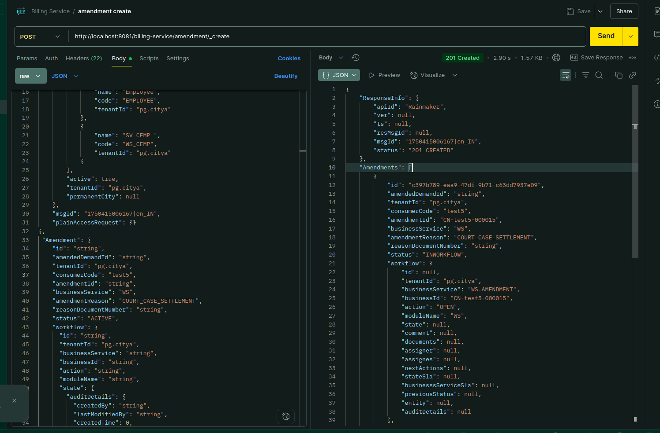

Environment via port-forward:

Response:
{
"ResponseInfo": {
"apiId": "Rainmaker",
"ver": null,
"ts": null,
"resMsgId": null,
"msgId": "1750415006167|en_IN",
"status": "201 CREATED"
},
"Amendments": [
{
"id": "c397b789-eaa9-47df-9b71-c63dd7937e09",
"amendedDemandId": "string",
"tenantId": "pg.citya",
"consumerCode": "test5",
"amendmentId": "CN-test5-000015",
"businessService": "WS",
"amendmentReason": "COURT_CASE_SETTLEMENT",
"reasonDocumentNumber": "string",
"status": "INWORKFLOW",
"workflow": {
"id": null,
"tenantId": "pg.citya",
"businessService": "WS.AMENDMENT",
"businessId": "CN-test5-000015",
"action": "OPEN",
"moduleName": "WS",
"state": null,
"comment": null,
"documents": null,
"assigner": null,
"assignes": null,
"nextActions": null,
"stateSla": null,
"businesssServiceSla": null,
"previousStatus": null,
"entity": null,
"auditDetails": null
},
"demandDetails": [
{
"id": "bae8c168-2c70-49f1-b9ef-368a8d1c568e",
"demandId": "string",
"taxHeadMasterCode": "WS_CHARGE",
"taxAmount": 0,
"collectionAmount": 0,
"additionalDetails": {},
"auditDetails": {
"createdBy": "string",
"lastModifiedBy": "string",
"createdTime": 0,
"lastModifiedTime": 0
},
"tenantId": "string"
}
],
"documents": [
{
"id": "565b3011-a1f3-4f3c-a653-52b9b1916d0c",
"documentType": "string",
"fileStoreId": "string",
"documentUid": "string",
"additionalDetails": {}
}
],
"effectiveFrom": 0,
"effectiveTill": 10,
"auditDetails": {
"createdBy": "9ff0b9bc-ae68-4a4d-a7ac-83f95257dc2d",
"lastModifiedBy": "9ff0b9bc-ae68-4a4d-a7ac-83f95257dc2d",
"createdTime": 1750923390705,
"lastModifiedTime": 1750923390705
},
"additionalDetails": {}
}
]
}

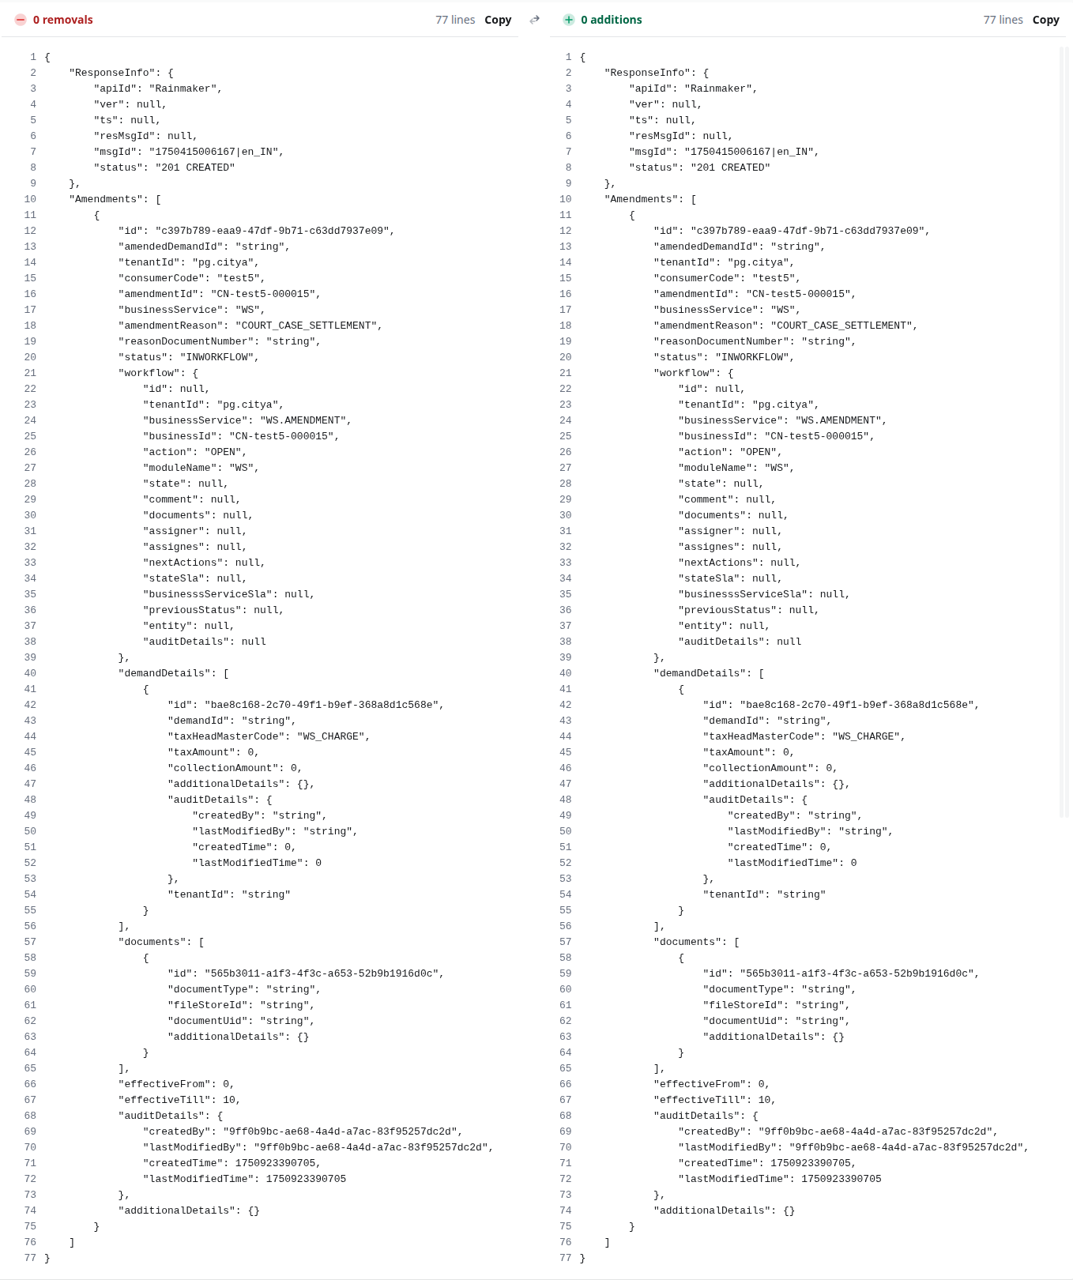

-Amendment Update:

Payload -curl:
curl --location 'http://localhost:8081/billing-service/amendment/_update' \
--header 'accept: application/json, text/plain, */*' \
--header 'accept-language: en-US,en;q=0.9' \
--header 'content-type: application/json;charset=UTF-8' \
--header 'origin: https://niuatt.niua.in' \
--header 'priority: u=1, i' \
--header 'referer: https://niuatt.niua.in/sv-ui/employee/payment/collect/sv-services/SV-1013-001437' \
--header 'sec-ch-ua: "Chromium";v="136", "Google Chrome";v="136", "Not.A/Brand";v="99"' \
--header 'sec-ch-ua-mobile: ?0' \
--header 'sec-ch-ua-platform: "Linux"' \
--header 'sec-fetch-dest: empty' \
--header 'sec-fetch-mode: cors' \
--header 'sec-fetch-site: same-origin' \
--header 'user-agent: Mozilla/5.0 (X11; Linux x86_64) AppleWebKit/537.36 (KHTML, like Gecko) Chrome/136.0.0.0 Safari/537.36' \
--data '{
"RequestInfo": {
"apiId": "Rainmaker",
"authToken": "d1d09aa5-804d-4663-8aa5-9b35c633de3d",
"userInfo": {
"id": 781,
"uuid": "d4304a81-8bc4-4d7c-a405-70cefbd498ba",
"userName": "SV_CEMP",
"name": "Street Vending",
"mobileNumber": "9810010199",
"emailId": null,
"locale": null,
"type": "EMPLOYEE",
"roles": [
{
"name": "Employee",
"code": "EMPLOYEE",
"tenantId": "pg.citya"
},
{
"name": "SV CEMP ",
"code": "WS_APPROVER",
"tenantId": "pg.citya"
}
],
"active": true,
"tenantId": "pg.citya",
"permanentCity": null
},
"msgId": "1750415006167|en_IN",
"plainAccessRequest": {}
},
"AmendmentUpdate": {
"status": "ACTIVE",
"amendmentId": "CN-string-000008",
"amendedDemandId": "string",
"tenantId": "pg.citya",
"auditDetails": {
"createdBy": "string",
"lastModifiedBy": "string",
"createdTime": 0,
"lastModifiedTime": 0
},
"additionalDetails": {},
"workflow": {
"id": "string",
"tenantId": "pg.citya",
"businessService": "WS.AMENDMENT",
"businessId": "string",
"action": "APPROVE",
"moduleName": "string",
"state": {
"auditDetails": {
"createdBy": "string",
"lastModifiedBy": "string",
"createdTime": 0,
"lastModifiedTime": 0
},
"uuid": "dd03b077-8546-418e-9f51-20782ef22b3a",
"tenantId": "pg.citya",
"businessServiceId": "string",
"sla": 0,
"state": "string",
"applicationStatus": "string",
"docUploadRequired": true,
"isStartState": true,
"isTerminateState": true,
"isStateUpdatable": true,
"actions": [
{
"auditDetails": {
"createdBy": "string",
"lastModifiedBy": "string",
"createdTime": 0,
"lastModifiedTime": 0
},
"uuid": "39c2c5ce-da70-4077-a9db-e50e9aaac87f",
"tenantId": "pg.citya",
"currentState": "string",
"action": "string",
"nextState": "string",
"roles": [
"string"
]
}
]
},
"comment": "string",
"documents": [
{
"id": "string",
"documentType": "string",
"fileStoreId": "string",
"documentUid": "string",
"additionalDetails": {}
}
],
"assigner": {
"id": 0,
"userName": "string",
"name": "string",
"type": "string",
"mobileNumber": "string",
"emailId": "string",
"roles": [
{
"id": 0,
"name": "string",
"code": "WS_CEMP",
"tenantId": "pg.citya"
}
],
"tenantId": "pg.citya",
"uuid": "f6ea5fb8-d872-4f47-8a37-ceea41759dea"
},

"stateSla": 0,
"businesssServiceSla": 0,
"previousStatus": "string",
"entity": {},
"auditDetails": {
"createdBy": "string",
"lastModifiedBy": "string",
"createdTime": 0,
"lastModifiedTime": 0
}
},
"documents": [
{
"id": "string",
"documentType": "string",
"fileStoreId": "string",
"documentUid": "string",
"additionalDetails": {}
}
],
"amendmentReason": "COURT_CASE_SETTLEMENT",
"reasonDocumentNumber": "string",
"effectiveFrom": 0,
"effectiveTill": 0
}
}'

Response:
{
"ResponseInfo": {
"apiId": "Rainmaker",
"ver": null,
"ts": null,
"resMsgId": null,
"msgId": "1750415006167|en_IN",
"status": "200 OK"
},
"Amendments": [
{
"id": "2d990a57-b34a-4a64-879b-22b8cc8fa328",
"amendedDemandId": "66799636-b357-4aa9-a367-4db2583e3878",
"tenantId": "pg.citya",
"consumerCode": "string",
"amendmentId": "CN-string-000008",
"businessService": "WS",
"amendmentReason": "COURT_CASE_SETTLEMENT",
"reasonDocumentNumber": "string",
"status": "CONSUMED",
"workflow": null,
"demandDetails": [
{
"id": "28e17155-d457-4a0d-8cc5-f79214a3d406",
"demandId": null,
"taxHeadMasterCode": "WS_CHARGE",
"taxAmount": 0.00,
"collectionAmount": 0,
"additionalDetails": null,
"auditDetails": null,
"tenantId": null
}
],
"documents": [
{
"id": "cca7bd58-f3e0-40ef-ab82-9ebbf4a35ce0",
"documentType": "string",
"fileStoreId": "string",
"documentUid": "string",
"additionalDetails": null
}
],
"effectiveFrom": 0,
"effectiveTill": 3,
"auditDetails": {
"createdBy": "9ff0b9bc-ae68-4a4d-a7ac-83f95257dc2d",
"lastModifiedBy": "d4304a81-8bc4-4d7c-a405-70cefbd498ba",
"createdTime": 1750744736790,
"lastModifiedTime": 1751446658742
},
"additionalDetails": {}
}
]
}

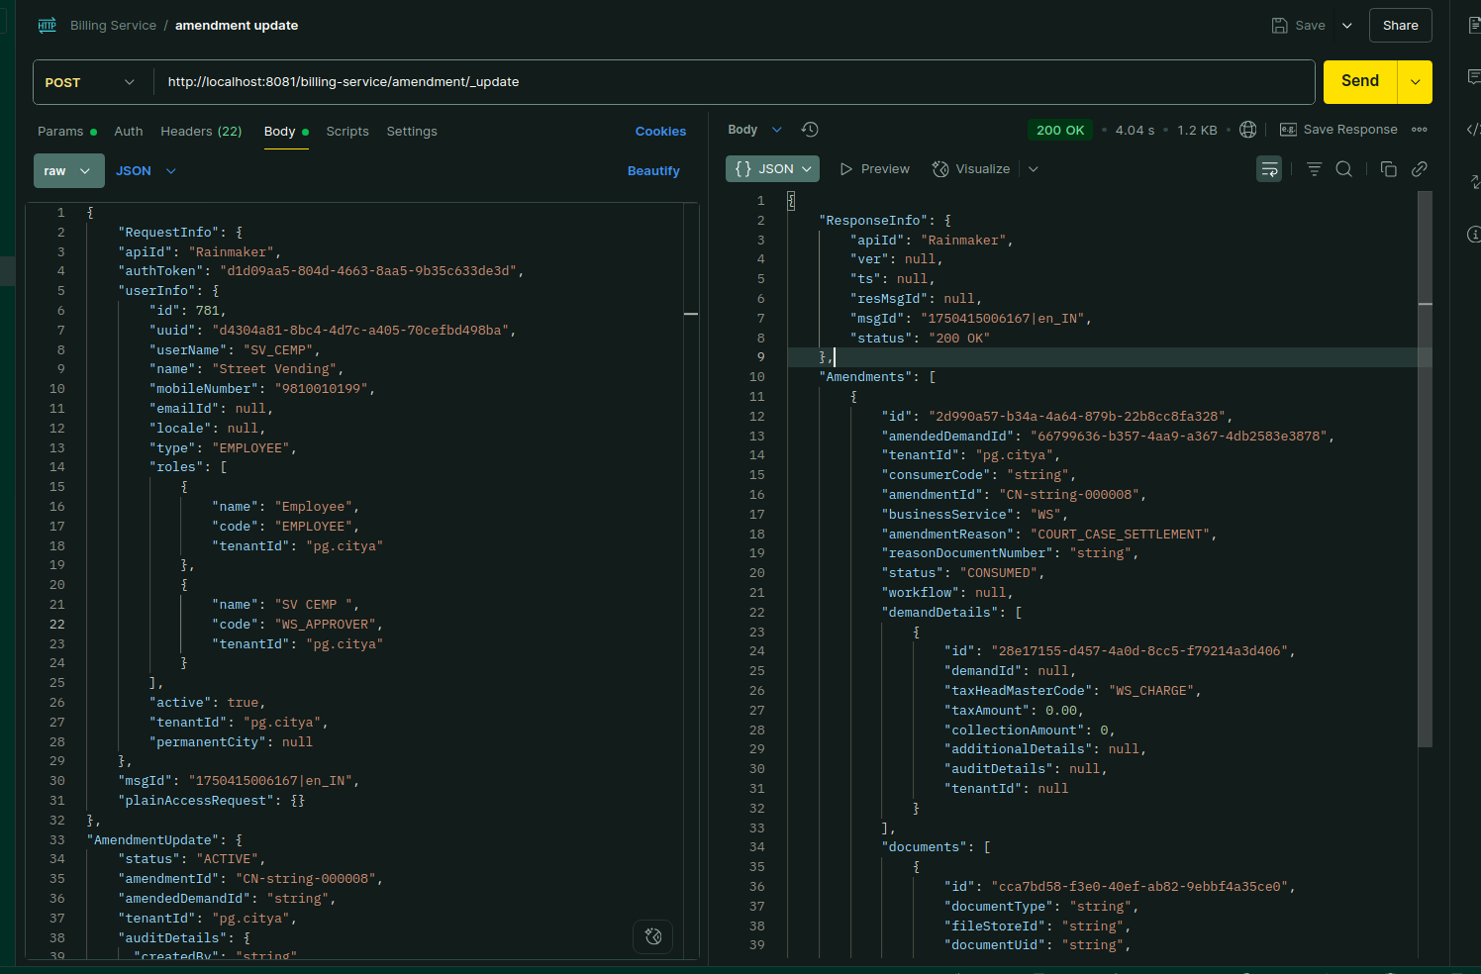

Environment via port-forward:

Response:
{
"ResponseInfo": {
"apiId": "Rainmaker",
"ver": null,
"ts": null,
"resMsgId": null,
"msgId": "1750415006167|en_IN",
"status": "200 OK"
},
"Amendments": [
{
"id": "2d990a57-b34a-4a64-879b-22b8cc8fa328",
"amendedDemandId": "66799636-b357-4aa9-a367-4db2583e3878",
"tenantId": "pg.citya",
"consumerCode": "string",
"amendmentId": "CN-string-000008",
"businessService": "WS",
"amendmentReason": "COURT_CASE_SETTLEMENT",
"reasonDocumentNumber": "string",
"status": "CONSUMED",
"workflow": null,
"demandDetails": [
{
"id": "28e17155-d457-4a0d-8cc5-f79214a3d406",
"demandId": null,
"taxHeadMasterCode": "WS_CHARGE",
"taxAmount": 0.00,
"collectionAmount": 0,
"additionalDetails": null,
"auditDetails": null,
"tenantId": null
}
],
"documents": [
{
"id": "cca7bd58-f3e0-40ef-ab82-9ebbf4a35ce0",
"documentType": "string",
"fileStoreId": "string",
"documentUid": "string",
"additionalDetails": null
}
],
"effectiveFrom": 0,
"effectiveTill": 3,
"auditDetails": {
"createdBy": "9ff0b9bc-ae68-4a4d-a7ac-83f95257dc2d",
"lastModifiedBy": "d4304a81-8bc4-4d7c-a405-70cefbd498ba",
"createdTime": 1750744736790,
"lastModifiedTime": 1751446658742
},
"additionalDetails": {}
}
]
}

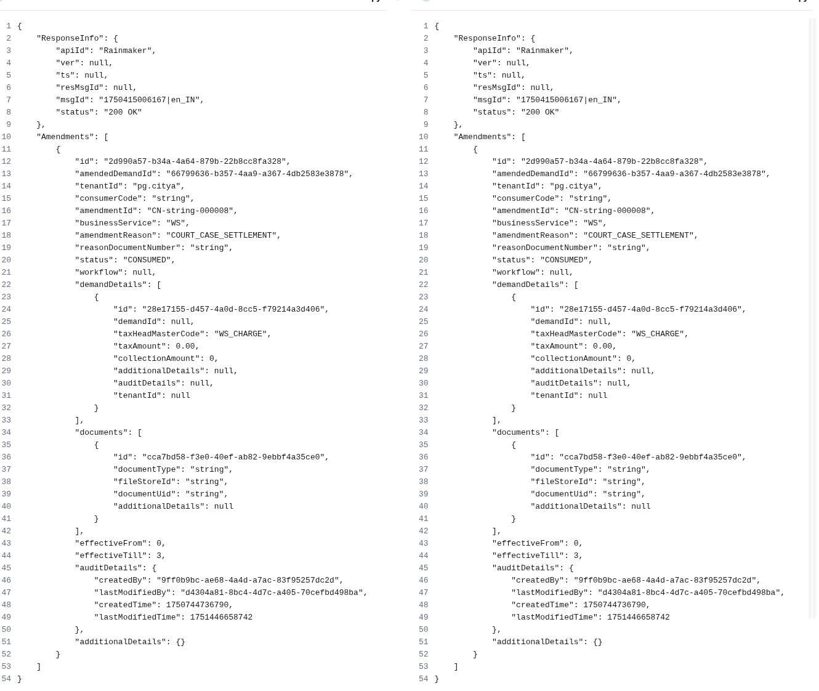

Tax Period Controller:

-Tax Period Search:

Payload -curl:
curl --location 'http://localhost:8081/billing-service/taxperiods/_search?tenantId=pg.citya&service=sv-services' \
--header 'accept: application/json, text/plain, */*' \
--header 'accept-language: en-US,en;q=0.9' \
--header 'content-type: application/json;charset=UTF-8' \
--header 'origin: https://niuatt.niua.in' \
--header 'priority: u=1, i' \
--header 'referer: https://niuatt.niua.in/sv-ui/employee/payment/collect/sv-services/SV-1013-001437' \
--header 'sec-ch-ua: "Chromium";v="136", "Google Chrome";v="136", "Not.A/Brand";v="99"' \
--header 'sec-ch-ua-mobile: ?0' \
--header 'sec-ch-ua-platform: "Linux"' \
--header 'sec-fetch-dest: empty' \
--header 'sec-fetch-mode: cors' \
--header 'sec-fetch-site: same-origin' \
--header 'user-agent: Mozilla/5.0 (X11; Linux x86_64) AppleWebKit/537.36 (KHTML, like Gecko) Chrome/136.0.0.0 Safari/537.36' \
--data '{
"RequestInfo": {
"apiId": "Rainmaker",
"authToken": "d1d09aa5-804d-4663-8aa5-9b35c633de3d",
"userInfo": {
"id": 781,
"uuid": "9ff0b9bc-ae68-4a4d-a7ac-83f95257dc2d",
"userName": "SV_CEMP",
"name": "Street Vending",
"mobileNumber": "9810010199",
"emailId": null,
"locale": null,
"type": "EMPLOYEE",
"roles": [
{
"name": "Employee",
"code": "EMPLOYEE",
"tenantId": "pg.citya"
},
{
"name": "SV CEMP ",
"code": "SVCEMP",
"tenantId": "pg.citya"
}
],
"active": true,
"tenantId": "pg.citya",
"permanentCity": null
},
"msgId": "1750415006167|en_IN",
"plainAccessRequest": {}
}
}'

Response:
{
"ResponseInfo": {
"apiId": "Rainmaker",
"ver": null,
"ts": null,
"resMsgId": null,
"msgId": "1750415006167|en_IN",
"status": "200 OK"
},
"TaxPeriods": [
{
"id": null,
"tenantId": null,
"fromDate": 1554057000000,
"toDate": 1869676199000,
"periodCycle": "ANNUAL",
"service": "sv-services",
"code": "SV_REGISTRATION_FEE",
"financialYear": "2024-25",
"auditDetail": null
}
]
}
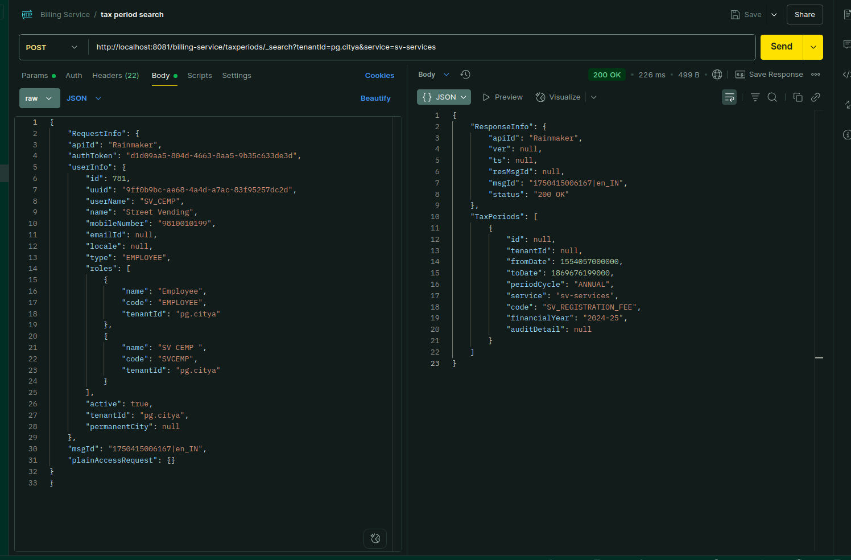

Environment via port-forward:

Response:

{
"ResponseInfo": {
"apiId": "Rainmaker",
"ver": null,
"ts": null,
"resMsgId": null,
"msgId": "1750415006167|en_IN",
"status": "200 OK"
},
"TaxPeriods": [
{
"id": null,
"tenantId": null,
"fromDate": 1554057000000,
"toDate": 1869676199000,
"periodCycle": "ANNUAL",
"service": "sv-services",
"code": "SV_REGISTRATION_FEE",
"financialYear": "2024-25",
"auditDetail": null
}
]
}
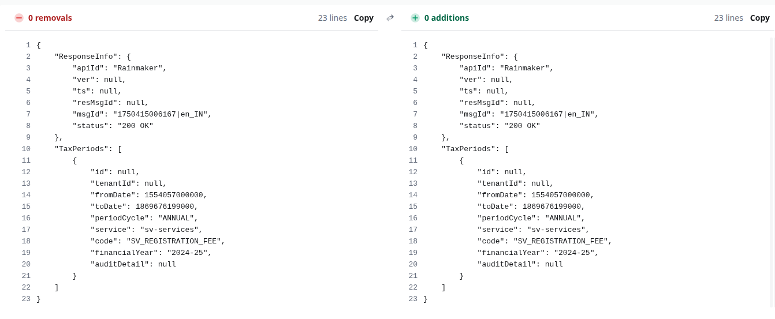

Tax Head Master Controller:

Tax Head Master Search:

Payload -curl:
curl --location 'http://localhost:8081/billing-service/taxheads/_search?tenantId=pg.citya&service=sv-services' \
--header 'accept: application/json, text/plain, */*' \
--header 'accept-language: en-US,en;q=0.9' \
--header 'content-type: application/json;charset=UTF-8' \
--header 'origin: https://niuatt.niua.in' \
--header 'priority: u=1, i' \
--header 'referer: https://niuatt.niua.in/sv-ui/employee/payment/collect/sv-services/SV-1013-001437' \
--header 'sec-ch-ua: "Chromium";v="136", "Google Chrome";v="136", "Not.A/Brand";v="99"' \
--header 'sec-ch-ua-mobile: ?0' \
--header 'sec-ch-ua-platform: "Linux"' \
--header 'sec-fetch-dest: empty' \
--header 'sec-fetch-mode: cors' \
--header 'sec-fetch-site: same-origin' \
--header 'user-agent: Mozilla/5.0 (X11; Linux x86_64) AppleWebKit/537.36 (KHTML, like Gecko) Chrome/136.0.0.0 Safari/537.36' \
--data '{
"RequestInfo": {
"apiId": "Rainmaker",
"authToken": "d1d09aa5-804d-4663-8aa5-9b35c633de3d",
"userInfo": {
"id": 781,
"uuid": "9ff0b9bc-ae68-4a4d-a7ac-83f95257dc2d",
"userName": "SV_CEMP",
"name": "Street Vending",
"mobileNumber": "9810010199",
"emailId": null,
"locale": null,
"type": "EMPLOYEE",
"roles": [
{
"name": "Employee",
"code": "EMPLOYEE",
"tenantId": "pg.citya"
},
{
"name": "SV CEMP ",
"code": "SVCEMP",
"tenantId": "pg.citya"
}
],
"active": true,
"tenantId": "pg.citya",
"permanentCity": null
},
"msgId": "1750415006167|en_IN",
"plainAccessRequest": {}
}
}'

Response:
{
"ResponseInfo": {
"apiId": "Rainmaker",
"ver": null,
"ts": null,
"resMsgId": null,
"msgId": "1750415006167|en_IN",
"status": "200 OK"
},
"TaxHeadMasters": [
{
"id": null,
"tenantId": null,
"category": "TAX",
"service": "PT",
"name": "Pt adhoc rebate",
"code": "PT_ADHOC_REBATE",
"glCodes": null,
"isDebit": true,
"isActualDemand": false,
"validFrom": null,
"validTill": null,
"order": 0,
"auditDetail": null
}
]
}

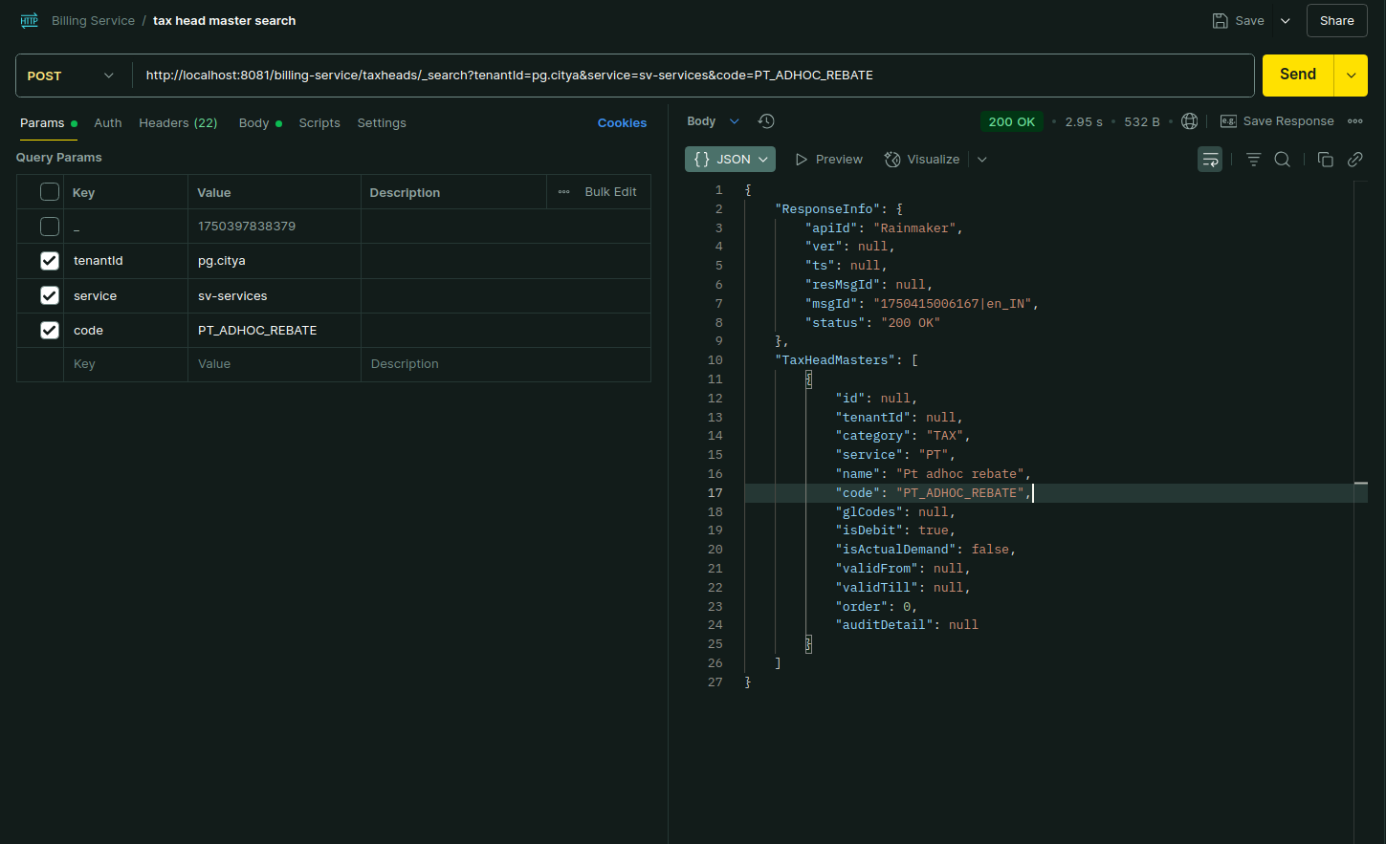

Environment via port-forward

Response:
{
"ResponseInfo": {
"apiId": "Rainmaker",
"ver": null,
"ts": null,
"resMsgId": null,
"msgId": "1750415006167|en_IN",
"status": "200 OK"
},
"TaxHeadMasters": [
{
"id": null,
"tenantId": null,
"category": "TAX",
"service": "PT",
"name": "Pt adhoc rebate",
"code": "PT_ADHOC_REBATE",
"glCodes": null,
"isDebit": true,
"isActualDemand": false,
"validFrom": null,
"validTill": null,
"order": 0,
"auditDetail": null
}
]
}

Business Service Detail Controller:

Business Service Detail Search:

Payload -curl:
curl --location 'http://localhost:8081/billing-service/businessservices/_search?tenantId=pg.citya&businessService=PT' \
--header 'accept: application/json, text/plain, */*' \
--header 'accept-language: en-US,en;q=0.9' \
--header 'content-type: application/json;charset=UTF-8' \
--header 'origin: https://niuatt.niua.in' \
--header 'priority: u=1, i' \
--header 'referer: https://niuatt.niua.in/sv-ui/employee/payment/collect/sv-services/SV-1013-001437' \
--header 'sec-ch-ua: "Chromium";v="136", "Google Chrome";v="136", "Not.A/Brand";v="99"' \
--header 'sec-ch-ua-mobile: ?0' \
--header 'sec-ch-ua-platform: "Linux"' \
--header 'sec-fetch-dest: empty' \
--header 'sec-fetch-mode: cors' \
--header 'sec-fetch-site: same-origin' \
--header 'user-agent: Mozilla/5.0 (X11; Linux x86_64) AppleWebKit/537.36 (KHTML, like Gecko) Chrome/136.0.0.0 Safari/537.36' \
--data '{
"RequestInfo": {
"apiId": "Rainmaker",
"authToken": "d1d09aa5-804d-4663-8aa5-9b35c633de3d",
"userInfo": {
"id": 781,
"uuid": "9ff0b9bc-ae68-4a4d-a7ac-83f95257dc2d",
"userName": "SV_CEMP",
"name": "Street Vending",
"mobileNumber": "9810010199",
"emailId": null,
"locale": null,
"type": "EMPLOYEE",
"roles": [
{
"name": "Employee",
"code": "EMPLOYEE",
"tenantId": "pg.citya"
},
{
"name": "SV CEMP ",
"code": "SVCEMP",
"tenantId": "pg.citya"
}
],
"active": true,
"tenantId": "pg.citya",
"permanentCity": null
},
"msgId": "1750415006167|en_IN",
"plainAccessRequest": {}
}
}'

Response:
{
"ResponseInfo": {
"apiId": "Rainmaker",
"ver": null,
"ts": null,
"resMsgId": null,
"msgId": "1750415006167|en_IN",
"status": "200 OK"
},
"BusinessServiceDetails": [
{
"id": null,
"tenantId": null,
"businessService": "PropertyTax",
"code": "PT",
"collectionModesNotAllowed": [
"DD",
"OFFLINE_NEFT",
"OFFLINE_RTGS",
"POSTAL_ORDER"
],
"partPaymentAllowed": true,
"isBillAmendmentEnabled": false,
"isAdvanceAllowed": false,
"demandUpdateTime": 86400000,
"callBackForApportioning": null,
"callBackApportionURL": null,
"auditDetails": null
}
]
}

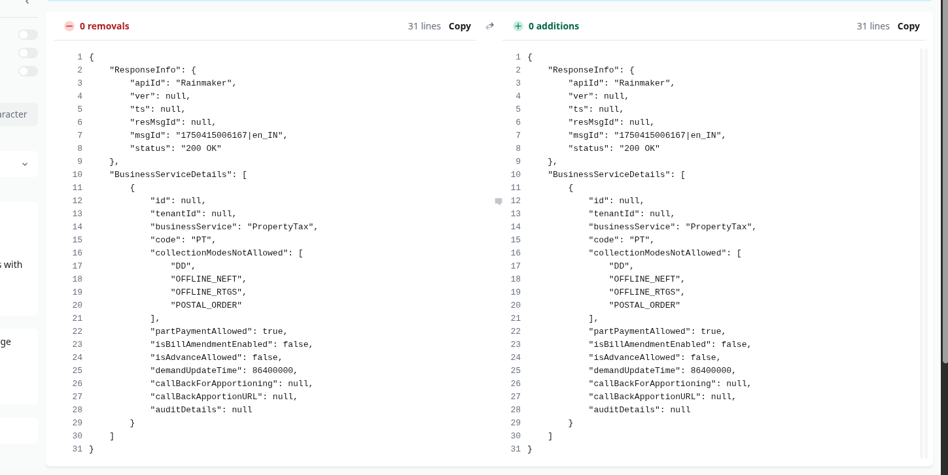

Environment via port-forward

Response:

{
"ResponseInfo": {
"apiId": "Rainmaker",
"ver": null,
"ts": null,
"resMsgId": null,
"msgId": "1750415006167|en_IN",
"status": "200 OK"
},
"BusinessServiceDetails": [
{
"id": null,
"tenantId": null,
"businessService": "PropertyTax",
"code": "PT",
"collectionModesNotAllowed": [
"DD",
"OFFLINE_NEFT",
"OFFLINE_RTGS",
"POSTAL_ORDER"
],
"partPaymentAllowed": true,
"isBillAmendmentEnabled": false,
"isAdvanceAllowed": false,
"demandUpdateTime": 86400000,
"callBackForApportioning": null,
"callBackApportionURL": null,
"auditDetails": null
}
]
}

Demand Controller:

Demand Search:

Payload -curl:
curl --location 'http://localhost:8081/billing-service/demand/_search?tenantId=pg.citya&businessService=WS&consumerCode=string' \
--header 'accept: application/json, text/plain, */*' \
--header 'accept-language: en-US,en;q=0.9' \
--header 'content-type: application/json;charset=UTF-8' \
--header 'origin: https://niuatt.niua.in' \
--header 'priority: u=1, i' \
--header 'referer: https://niuatt.niua.in/sv-ui/employee/payment/collect/sv-services/SV-1013-001437' \
--header 'sec-ch-ua: "Chromium";v="136", "Google Chrome";v="136", "Not.A/Brand";v="99"' \
--header 'sec-ch-ua-mobile: ?0' \
--header 'sec-ch-ua-platform: "Linux"' \
--header 'sec-fetch-dest: empty' \
--header 'sec-fetch-mode: cors' \
--header 'sec-fetch-site: same-origin' \
--header 'user-agent: Mozilla/5.0 (X11; Linux x86_64) AppleWebKit/537.36 (KHTML, like Gecko) Chrome/136.0.0.0 Safari/537.36' \
--data '{
"RequestInfo": {
"apiId": "Rainmaker",
"authToken": "d1d09aa5-804d-4663-8aa5-9b35c633de3d",
"userInfo": {
"id": 781,
"uuid": "9ff0b9bc-ae68-4a4d-a7ac-83f95257dc2d",
"userName": "SV_CEMP",
"name": "Street Vending",
"mobileNumber": "9810010199",
"emailId": null,
"locale": null,
"type": "EMPLOYEE",
"roles": [
{
"name": "Employee",
"code": "EMPLOYEE",
"tenantId": "pg.citya"
},
{
"name": "SV CEMP ",
"code": "SVCEMP",
"tenantId": "pg.citya"
}
],
"active": true,
"tenantId": "pg.citya",
"permanentCity": null
},
"msgId": "1750415006167|en_IN",
"plainAccessRequest": {}
}
}'

Response:
{
"ResponseInfo": {
"apiId": "Rainmaker",
"ver": null,
"ts": null,
"resMsgId": null,
"msgId": "1750415006167|en_IN",
"status": "200 OK"
},
"Demands": [
{
"isPaymentCompleted": false,
"id": "66799636-b357-4aa9-a367-4db2583e3878",
"tenantId": "pg.citya",
"consumerCode": "string",
"consumerType": "string",
"businessService": "WS",
"payer": {
"uuid": "bfa37bfa-d569-4b27-893f-fb050b8eb2bd",
"id": 747,
"userName": "INTERNAL_USER",
"type": "SYSTEM",
"salutation": null,
"name": "Internal Microservice User",
"gender": null,
"mobileNumber": "9999999999",
"emailId": null,
"altContactNumber": null,
"pan": null,
"aadhaarNumber": null,
"permanentAddress": null,
"permanentCity": null,
"permanentPinCode": null,
"correspondenceAddress": null,
"correspondenceCity": null,
"correspondencePinCode": null,
"active": true,
"tenantId": "pg"
},
"taxPeriodFrom": 1717058721822,
"taxPeriodTo": 1817058721822,
"demandDetails": [
{
"id": "7e1cd07b-4a7a-4b0f-8bee-458c3d3807db",
"demandId": "66799636-b357-4aa9-a367-4db2583e3878",
"taxHeadMasterCode": "WS_CHARGE",
"taxAmount": 0.00,
"collectionAmount": 0.00,
"additionalDetails": null,
"auditDetails": {
"createdBy": "9ff0b9bc-ae68-4a4d-a7ac-83f95257dc2d",
"lastModifiedBy": "9ff0b9bc-ae68-4a4d-a7ac-83f95257dc2d",
"createdTime": 1750937344666,
"lastModifiedTime": 1750937344666
},
"tenantId": "pg.citya"
}
],
"auditDetails": {
"createdBy": "9ff0b9bc-ae68-4a4d-a7ac-83f95257dc2d",
"lastModifiedBy": "9ff0b9bc-ae68-4a4d-a7ac-83f95257dc2d",
"createdTime": 1750937344666,
"lastModifiedTime": 1750937344666
},
"fixedBillExpiryDate": null,
"billExpiryTime": 0,
"additionalDetails": {},
"minimumAmountPayable": 0.00,
"status": "ACTIVE"
}
],
"CollectedReceipt": null
}

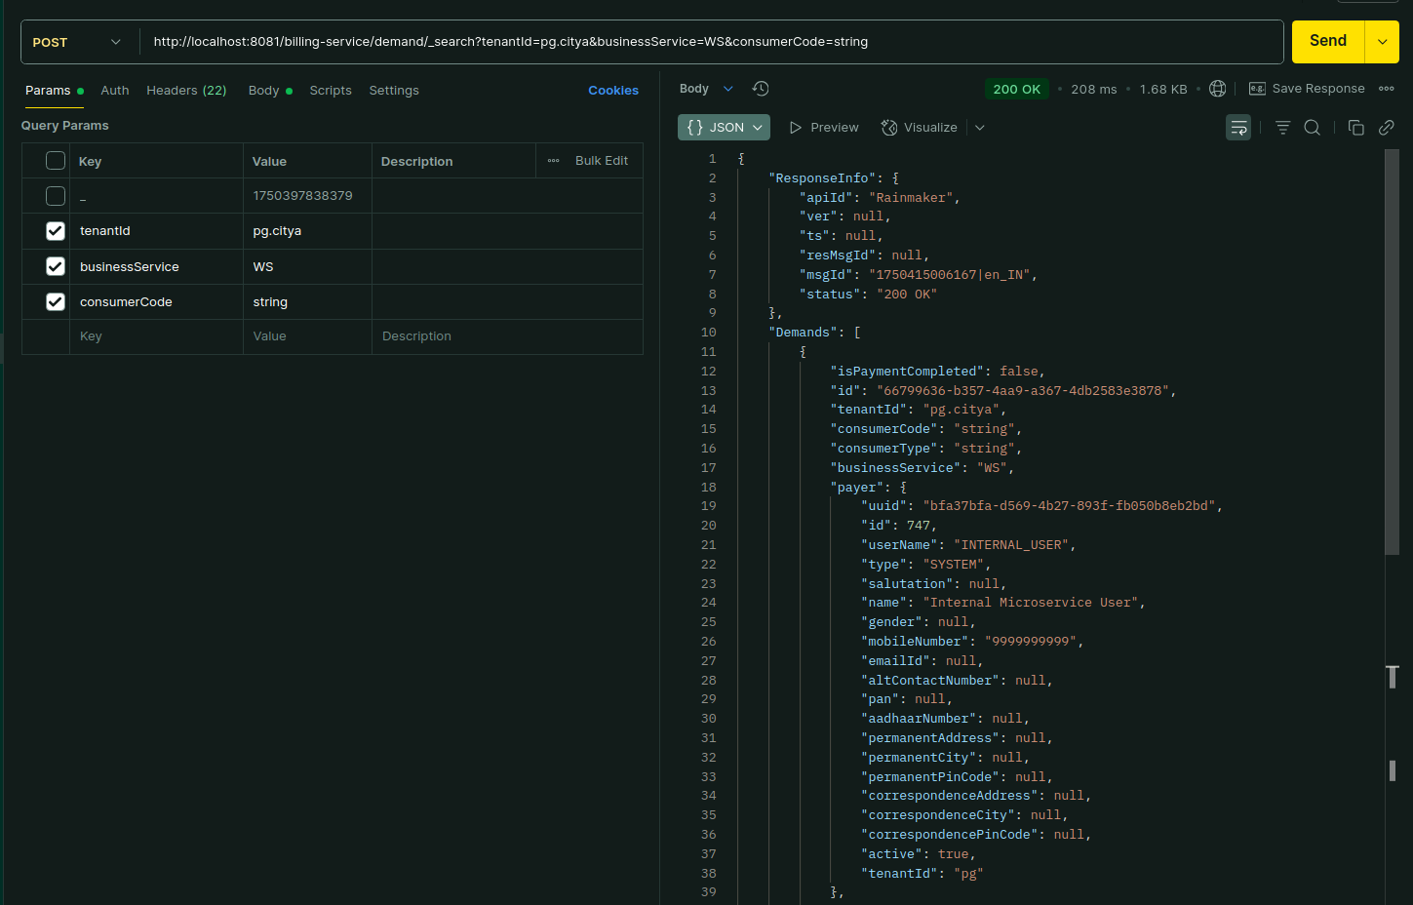
Environment via port-forward

Response:

{
"ResponseInfo": {
"apiId": "Rainmaker",
"ver": null,
"ts": null,
"resMsgId": null,
"msgId": "1750415006167|en_IN",
"status": "200 OK"
},
"Demands": [
{
"isPaymentCompleted": false,
"id": "66799636-b357-4aa9-a367-4db2583e3878",
"tenantId": "pg.citya",
"consumerCode": "string",
"consumerType": "string",
"businessService": "WS",
"payer": {
"uuid": "bfa37bfa-d569-4b27-893f-fb050b8eb2bd",
"id": 747,
"userName": "INTERNAL_USER",
"type": "SYSTEM",
"salutation": null,
"name": "Internal Microservice User",
"gender": null,
"mobileNumber": "9999999999",
"emailId": null,
"altContactNumber": null,
"pan": null,
"aadhaarNumber": null,
"permanentAddress": null,
"permanentCity": null,
"permanentPinCode": null,
"correspondenceAddress": null,
"correspondenceCity": null,
"correspondencePinCode": null,
"active": true,
"tenantId": "pg"
},
"taxPeriodFrom": 1717058721822,
"taxPeriodTo": 1817058721822,
"demandDetails": [
{
"id": "7e1cd07b-4a7a-4b0f-8bee-458c3d3807db",
"demandId": "66799636-b357-4aa9-a367-4db2583e3878",
"taxHeadMasterCode": "WS_CHARGE",
"taxAmount": 0.00,
"collectionAmount": 0.00,
"additionalDetails": null,
"auditDetails": {
"createdBy": "9ff0b9bc-ae68-4a4d-a7ac-83f95257dc2d",
"lastModifiedBy": "9ff0b9bc-ae68-4a4d-a7ac-83f95257dc2d",
"createdTime": 1750937344666,
"lastModifiedTime": 1750937344666
},
"tenantId": "pg.citya"
}
],
"auditDetails": {
"createdBy": "9ff0b9bc-ae68-4a4d-a7ac-83f95257dc2d",
"lastModifiedBy": "9ff0b9bc-ae68-4a4d-a7ac-83f95257dc2d",
"createdTime": 1750937344666,
"lastModifiedTime": 1750937344666
},
"fixedBillExpiryDate": null,
"billExpiryTime": 0,
"additionalDetails": {},
"minimumAmountPayable": 0.00,
"status": "ACTIVE"
}
],
"CollectedReceipt": null
}

Demand Create:

Payload -curl:
curl --location 'http://localhost:8081/billing-service/demand/_create' \
--header 'accept: application/json, text/plain, */*' \
--header 'accept-language: en-US,en;q=0.9' \
--header 'content-type: application/json;charset=UTF-8' \
--header 'origin: https://niuatt.niua.in' \
--header 'priority: u=1, i' \
--header 'referer: https://niuatt.niua.in/sv-ui/employee/payment/collect/sv-services/SV-1013-001437' \
--header 'sec-ch-ua: "Chromium";v="136", "Google Chrome";v="136", "Not.A/Brand";v="99"' \
--header 'sec-ch-ua-mobile: ?0' \
--header 'sec-ch-ua-platform: "Linux"' \
--header 'sec-fetch-dest: empty' \
--header 'sec-fetch-mode: cors' \
--header 'sec-fetch-site: same-origin' \
--header 'user-agent: Mozilla/5.0 (X11; Linux x86_64) AppleWebKit/537.36 (KHTML, like Gecko) Chrome/136.0.0.0 Safari/537.36' \
--data '{
"RequestInfo": {
"apiId": "Rainmaker",
"authToken": "d1d09aa5-804d-4663-8aa5-9b35c633de3d",
"userInfo": {
"id": 781,
"uuid": "9ff0b9bc-ae68-4a4d-a7ac-83f95257dc2d",
"userName": "SV_CEMP",
"name": "Street Vending",
"mobileNumber": "9810010199",
"emailId": null,
"locale": null,
"type": "EMPLOYEE",
"roles": [
{
"name": "Employee",
"code": "EMPLOYEE",
"tenantId": "pg.citya"
},
{
"name": "SV CEMP ",
"code": "WS_CHARGE",
"tenantId": "pg.citya"
}
],
"active": true,
"tenantId": "pg.citya",
"permanentCity": null
},
"msgId": "1750415006167|en_IN",
"plainAccessRequest": {}
},
"Demands": [
{
"isPaymentCompleted": true,
"id": "string",
"tenantId": "pg.citya",
"consumerCode": "string",
"consumerType": "string",
"businessService": "WS",
"payer": {
"id": 0,
"userName": "string",
"name": "string",
"type": "string",
"mobileNumber": "string",
"emailId": "string",
"roles": [
{
"id": 0,
"name": "string",
"code": "string",
"tenantId": "string"
}
],
"tenantId": "string",
"uuid": "bfa37bfa-d569-4b27-893f-fb050b8eb2bd"
},
"taxPeriodFrom": 1717058721822,
"taxPeriodTo": 1817058721822,
"demandDetails": [
{
"id": "string",
"demandId": "string",
"taxHeadMasterCode": "WS_CHARGE",
"taxAmount": 0,
"collectionAmount": 0,
"additionalDetails": {},
"auditDetails": {
"createdBy": "string",
"lastModifiedBy": "string",
"createdTime": 0,
"lastModifiedTime": 0
},
"tenantId": "string"
}
],
"auditDetails": {
"createdBy": "string",
"lastModifiedBy": "string",
"createdTime": 0,
"lastModifiedTime": 0
},
"fixedBillExpiryDate": 0,
"billExpiryTime": 0,
"additionalDetails": {},
"minimumAmountPayable": 0,
"status": "ACTIVE"
}
]
}'

Response:
{
"ResponseInfo": {
"apiId": "Rainmaker",
"ver": null,
"ts": null,
"resMsgId": null,
"msgId": "1750415006167|en_IN",
"status": "201 CREATED"
},
"Demands": [
{
"isPaymentCompleted": true,
"id": "66799636-b357-4aa9-a367-4db2583e3878",
"tenantId": "pg.citya",
"consumerCode": "string",
"consumerType": "string",
"businessService": "WS",
"payer": {
"uuid": "bfa37bfa-d569-4b27-893f-fb050b8eb2bd",
"id": 747,
"userName": "INTERNAL_USER",
"type": "SYSTEM",
"salutation": null,
"name": "Internal Microservice User",
"gender": null,
"mobileNumber": "9999999999",
"emailId": null,
"altContactNumber": null,
"pan": null,
"aadhaarNumber": null,
"permanentAddress": null,
"permanentCity": null,
"permanentPinCode": null,
"correspondenceAddress": null,
"correspondenceCity": null,
"correspondencePinCode": null,
"active": true,
"tenantId": "pg"
},
"taxPeriodFrom": 1717058721822,
"taxPeriodTo": 1817058721822,
"demandDetails": [
{
"id": "7e1cd07b-4a7a-4b0f-8bee-458c3d3807db",
"demandId": "66799636-b357-4aa9-a367-4db2583e3878",
"taxHeadMasterCode": "WS_CHARGE",
"taxAmount": 0,
"collectionAmount": 0,
"additionalDetails": {},
"auditDetails": {
"createdBy": "9ff0b9bc-ae68-4a4d-a7ac-83f95257dc2d",
"lastModifiedBy": "9ff0b9bc-ae68-4a4d-a7ac-83f95257dc2d",
"createdTime": 1750937344666,
"lastModifiedTime": 1750937344666
},
"tenantId": "pg.citya"
}
],
"auditDetails": {
"createdBy": "9ff0b9bc-ae68-4a4d-a7ac-83f95257dc2d",
"lastModifiedBy": "9ff0b9bc-ae68-4a4d-a7ac-83f95257dc2d",
"createdTime": 1750937344666,
"lastModifiedTime": 1750937344666
},
"fixedBillExpiryDate": 0,
"billExpiryTime": 0,
"additionalDetails": {},
"minimumAmountPayable": 0,
"status": "ACTIVE"
}
],
"CollectedReceipt": null
}

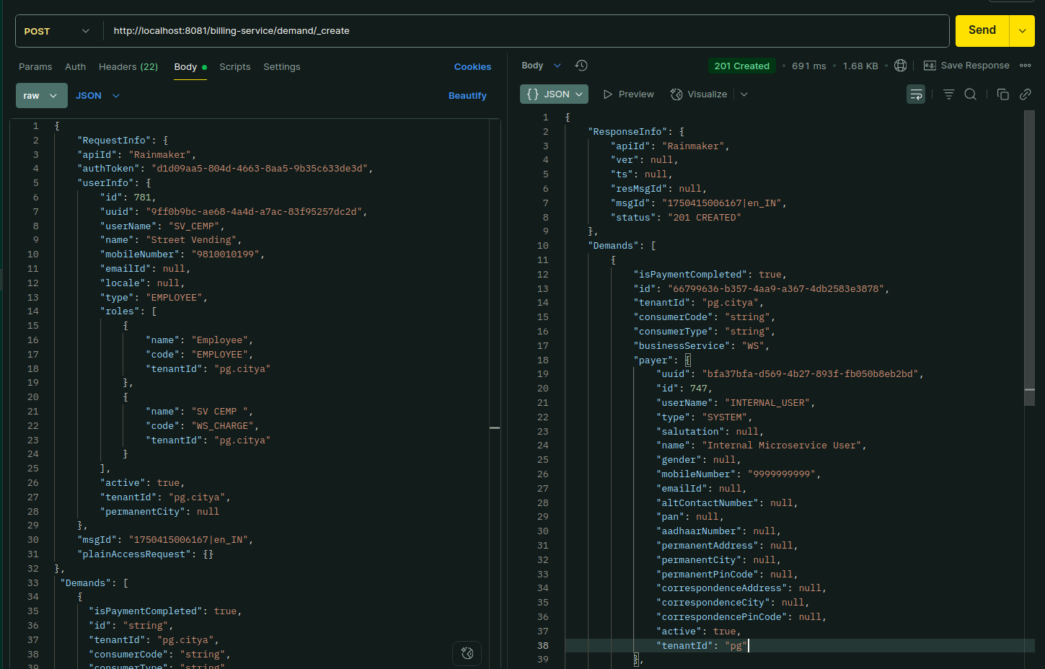

Environment via port-forward

Response:

{
"ResponseInfo": {
"apiId": "Rainmaker",
"ver": null,
"ts": null,
"resMsgId": null,
"msgId": "1750415006167|en_IN",
"status": "201 CREATED"
},
"Demands": [
{
"isPaymentCompleted": true,
"id": "66799636-b357-4aa9-a367-4db2583e3878",
"tenantId": "pg.citya",
"consumerCode": "string",
"consumerType": "string",
"businessService": "WS",
"payer": {
"uuid": "bfa37bfa-d569-4b27-893f-fb050b8eb2bd",
"id": 747,
"userName": "INTERNAL_USER",
"type": "SYSTEM",
"salutation": null,
"name": "Internal Microservice User",
"gender": null,
"mobileNumber": "9999999999",
"emailId": null,
"altContactNumber": null,
"pan": null,
"aadhaarNumber": null,
"permanentAddress": null,
"permanentCity": null,
"permanentPinCode": null,
"correspondenceAddress": null,
"correspondenceCity": null,
"correspondencePinCode": null,
"active": true,
"tenantId": "pg"
},
"taxPeriodFrom": 1717058721822,
"taxPeriodTo": 1817058721822,
"demandDetails": [
{
"id": "7e1cd07b-4a7a-4b0f-8bee-458c3d3807db",
"demandId": "66799636-b357-4aa9-a367-4db2583e3878",
"taxHeadMasterCode": "WS_CHARGE",
"taxAmount": 0,
"collectionAmount": 0,
"additionalDetails": {},
"auditDetails": {
"createdBy": "9ff0b9bc-ae68-4a4d-a7ac-83f95257dc2d",
"lastModifiedBy": "9ff0b9bc-ae68-4a4d-a7ac-83f95257dc2d",
"createdTime": 1750937344666,
"lastModifiedTime": 1750937344666
},
"tenantId": "pg.citya"
}
],
"auditDetails": {
"createdBy": "9ff0b9bc-ae68-4a4d-a7ac-83f95257dc2d",
"lastModifiedBy": "9ff0b9bc-ae68-4a4d-a7ac-83f95257dc2d",
"createdTime": 1750937344666,
"lastModifiedTime": 1750937344666
},
"fixedBillExpiryDate": 0,
"billExpiryTime": 0,
"additionalDetails": {},
"minimumAmountPayable": 0,
"status": "ACTIVE"
}
],
"CollectedReceipt": null
}

Demand Update:

Payload -curl:
curl --location 'http://localhost:8081/billing-service/demand/_update' \
--header 'accept: application/json, text/plain, */*' \
--header 'accept-language: en-US,en;q=0.9' \
--header 'content-type: application/json;charset=UTF-8' \
--header 'origin: https://niuatt.niua.in' \
--header 'priority: u=1, i' \
--header 'referer: https://niuatt.niua.in/sv-ui/employee/payment/collect/sv-services/SV-1013-001437' \
--header 'sec-ch-ua: "Chromium";v="136", "Google Chrome";v="136", "Not.A/Brand";v="99"' \
--header 'sec-ch-ua-mobile: ?0' \
--header 'sec-ch-ua-platform: "Linux"' \
--header 'sec-fetch-dest: empty' \
--header 'sec-fetch-mode: cors' \
--header 'sec-fetch-site: same-origin' \
--header 'user-agent: Mozilla/5.0 (X11; Linux x86_64) AppleWebKit/537.36 (KHTML, like Gecko) Chrome/136.0.0.0 Safari/537.36' \
--data '{
"RequestInfo": {
"apiId": "Rainmaker",
"authToken": "d1d09aa5-804d-4663-8aa5-9b35c633de3d",
"userInfo": {
"id": 781,
"uuid": "9ff0b9bc-ae68-4a4d-a7ac-83f95257dc2d",
"userName": "SV_CEMP",
"name": "Street Vending",
"mobileNumber": "9810010199",
"emailId": null,
"locale": null,
"type": "EMPLOYEE",
"roles": [
{
"name": "Employee",
"code": "EMPLOYEE",
"tenantId": "pg.citya"
},
{
"name": "SV CEMP ",
"code": "WS_CHARGE",
"tenantId": "pg.citya"
}
],
"active": true,
"tenantId": "pg.citya",
"permanentCity": null
},
"msgId": "1750415006167|en_IN",
"plainAccessRequest": {}
},
"Demands": [
{
"isPaymentCompleted": true,
"id": "66799636-b357-4aa9-a367-4db2583e3878",
"tenantId": "pg.citya",
"consumerCode": "string",
"consumerType": "string",
"businessService": "WS",
"payer": {
"id": 0,
"userName": "string",
"name": "string",
"type": "string",
"mobileNumber": "string",
"emailId": "string",
"roles": [
{
"id": 0,
"name": "string",
"code": "string",
"tenantId": "string"
}
],
"tenantId": "string",
"uuid": "bfa37bfa-d569-4b27-893f-fb050b8eb2bd"
},
"taxPeriodFrom": 1717058721822,
"taxPeriodTo": 1817058721822,
"demandDetails": [
{
"id": "7e1cd07b-4a7a-4b0f-8bee-458c3d3807db",
"demandId": "string",
"taxHeadMasterCode": "WS_CHARGE",
"taxAmount": 0,
"collectionAmount": 0,
"additionalDetails": {},
"auditDetails": {
"createdBy": "string",
"lastModifiedBy": "string",
"createdTime": 0,
"lastModifiedTime": 0
},
"tenantId": "string"
}
],
"auditDetails": {
"createdBy": "string",
"lastModifiedBy": "string",
"createdTime": 0,
"lastModifiedTime": 0
},
"fixedBillExpiryDate": 0,
"billExpiryTime": 0,
"additionalDetails": {},
"minimumAmountPayable": 0,
"status": "ACTIVE"
}
]
}'

Response:
{
"ResponseInfo": {
"apiId": "Rainmaker",
"ver": null,
"ts": null,
"resMsgId": null,
"msgId": "1750415006167|en_IN",
"status": "201 CREATED"
},
"Demands": [
{
"isPaymentCompleted": false,
"id": "66799636-b357-4aa9-a367-4db2583e3878",
"tenantId": "pg.citya",
"consumerCode": "string",
"consumerType": "string",
"businessService": "WS",
"payer": {
"uuid": "bfa37bfa-d569-4b27-893f-fb050b8eb2bd",
"id": 747,
"userName": "INTERNAL_USER",
"type": "SYSTEM",
"salutation": null,
"name": "Internal Microservice User",
"gender": null,
"mobileNumber": "9999999999",
"emailId": null,
"altContactNumber": null,
"pan": null,
"aadhaarNumber": null,
"permanentAddress": null,
"permanentCity": null,
"permanentPinCode": null,
"correspondenceAddress": null,
"correspondenceCity": null,
"correspondencePinCode": null,
"active": true,
"tenantId": "pg"
},
"taxPeriodFrom": 1717058721822,
"taxPeriodTo": 1817058721822,
"demandDetails": [
{
"id": "7e1cd07b-4a7a-4b0f-8bee-458c3d3807db",
"demandId": "66799636-b357-4aa9-a367-4db2583e3878",
"taxHeadMasterCode": "WS_CHARGE",
"taxAmount": 0,
"collectionAmount": 0,
"additionalDetails": {},
"auditDetails": {
"createdBy": "9ff0b9bc-ae68-4a4d-a7ac-83f95257dc2d",
"lastModifiedBy": "9ff0b9bc-ae68-4a4d-a7ac-83f95257dc2d",
"createdTime": 1750937716189,
"lastModifiedTime": 1750937716189
},
"tenantId": "pg.citya"
}
],
"auditDetails": {
"createdBy": "9ff0b9bc-ae68-4a4d-a7ac-83f95257dc2d",
"lastModifiedBy": "9ff0b9bc-ae68-4a4d-a7ac-83f95257dc2d",
"createdTime": 1750937716189,
"lastModifiedTime": 1750937716189
},
"fixedBillExpiryDate": 0,
"billExpiryTime": 0,
"additionalDetails": {},
"minimumAmountPayable": 0,
"status": "ACTIVE"
}
],
"CollectedReceipt": null
}

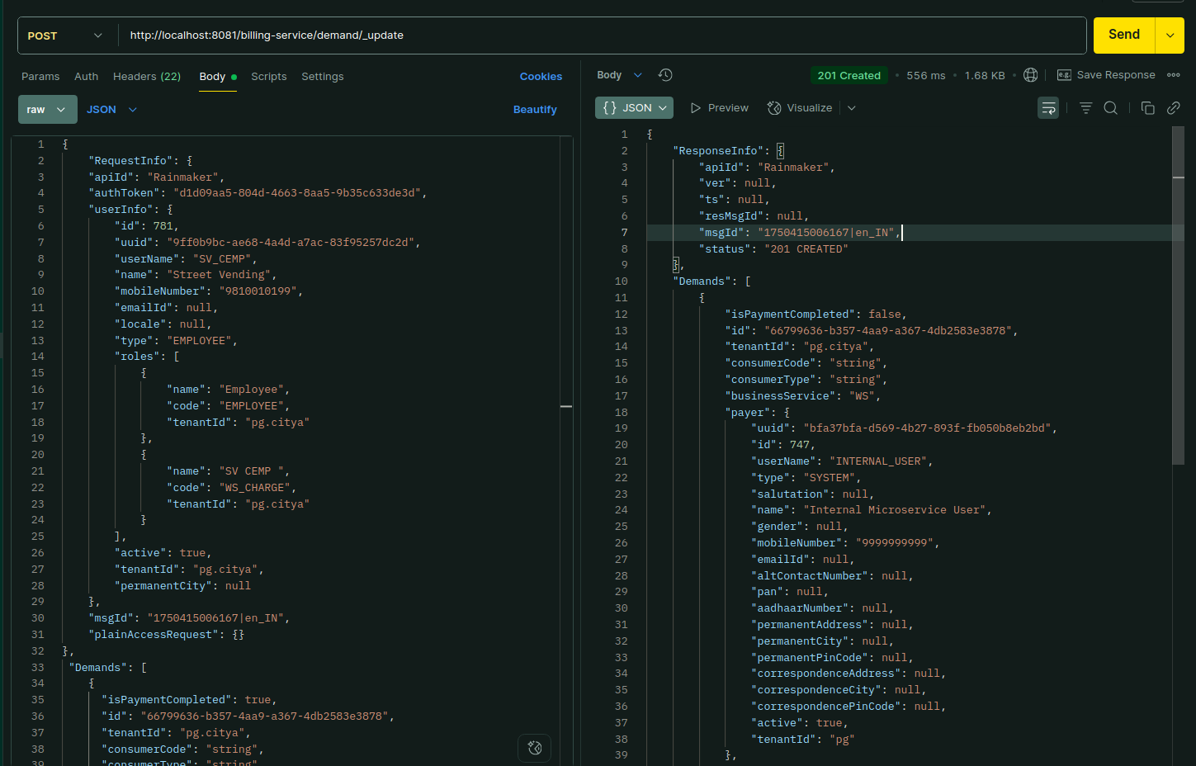
Environment via port-forward

Response:

{
"ResponseInfo": {
"apiId": "Rainmaker",
"ver": null,
"ts": null,
"resMsgId": null,
"msgId": "1750415006167|en_IN",
"status": "201 CREATED"
},
"Demands": [
{
"isPaymentCompleted": false,
"id": "66799636-b357-4aa9-a367-4db2583e3878",
"tenantId": "pg.citya",
"consumerCode": "string",
"consumerType": "string",
"businessService": "WS",
"payer": {
"uuid": "bfa37bfa-d569-4b27-893f-fb050b8eb2bd",
"id": 747,
"userName": "INTERNAL_USER",
"type": "SYSTEM",
"salutation": null,
"name": "Internal Microservice User",
"gender": null,
"mobileNumber": "9999999999",
"emailId": null,
"altContactNumber": null,
"pan": null,
"aadhaarNumber": null,
"permanentAddress": null,
"permanentCity": null,
"permanentPinCode": null,
"correspondenceAddress": null,
"correspondenceCity": null,
"correspondencePinCode": null,
"active": true,
"tenantId": "pg"
},
"taxPeriodFrom": 1717058721822,
"taxPeriodTo": 1817058721822,
"demandDetails": [
{
"id": "7e1cd07b-4a7a-4b0f-8bee-458c3d3807db",
"demandId": "66799636-b357-4aa9-a367-4db2583e3878",
"taxHeadMasterCode": "WS_CHARGE",
"taxAmount": 0,
"collectionAmount": 0,
"additionalDetails": {},
"auditDetails": {
"createdBy": "9ff0b9bc-ae68-4a4d-a7ac-83f95257dc2d",
"lastModifiedBy": "9ff0b9bc-ae68-4a4d-a7ac-83f95257dc2d",
"createdTime": 1750937716189,
"lastModifiedTime": 1750937716189
},
"tenantId": "pg.citya"
}
],
"auditDetails": {
"createdBy": "9ff0b9bc-ae68-4a4d-a7ac-83f95257dc2d",
"lastModifiedBy": "9ff0b9bc-ae68-4a4d-a7ac-83f95257dc2d",
"createdTime": 1750937716189,
"lastModifiedTime": 1750937716189
},
"fixedBillExpiryDate": 0,
"billExpiryTime": 0,
"additionalDetails": {},
"minimumAmountPayable": 0,
"status": "ACTIVE"
}
],
"CollectedReceipt": null
}

